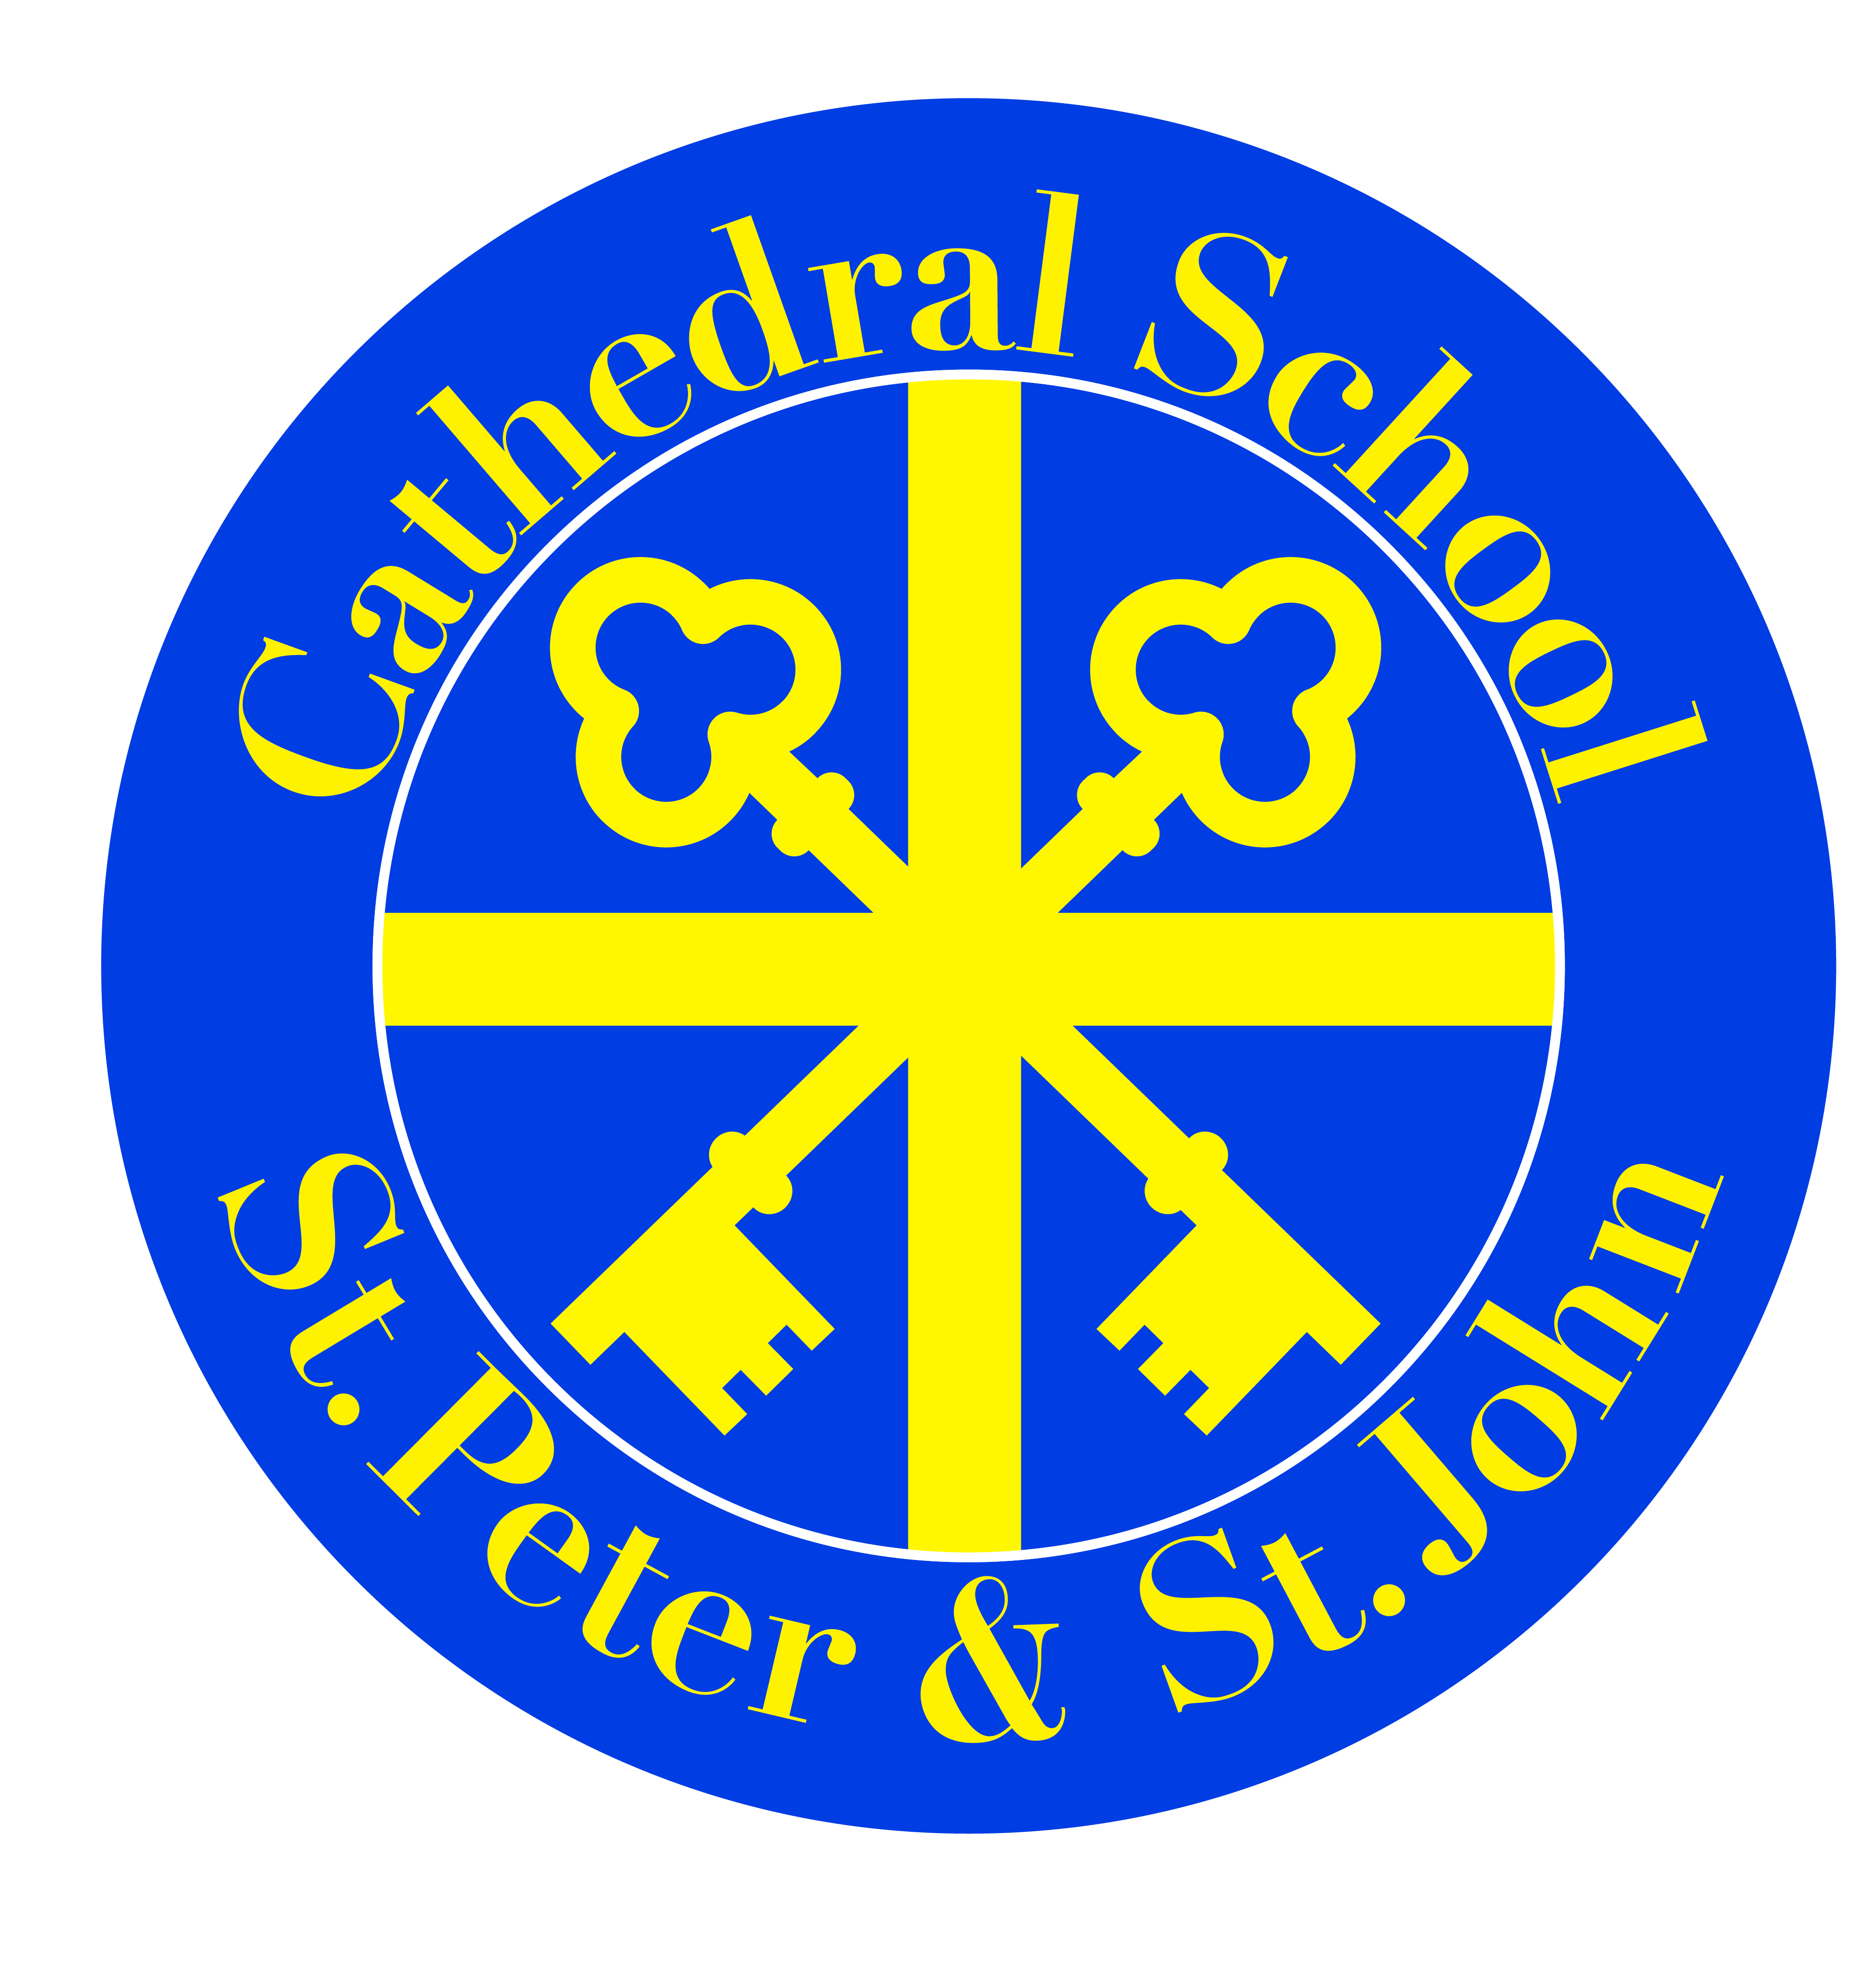
Head Teacher:
Mrs D Hanley
Mount Street
Salford.
M3 6LU
Tel: 0161 834 4150
E-mail: stpeter&stjohn@Salford.gov.uk
Web: www.cathedralschoolstpeterandjohn.com

The Cathedral School of St Peter and St John RC Primary
‘Growing together within God’s loving family, we support, challenge and inspire each
other to become the best that we can be’

Dear Parents/Carers,

Thank you for your support over the past few weeks. The Reception children have settled back into the EYFS unit really well after such a long time off and the new children have been amazing during their transition into our Nursery.

For the past eight years our EYFS unit has followed the DfE EYFS Statutory Framework (2012). Next year the framework is changing and as a result of these changes, schools were given the opportunity to become ‘early adopters’ of the new framework.

As a school, we have chosen to be an ‘early adopter’ school and implement this new framework. As such, we have a statutory responsibility of informing you, as parents, of this. We believe the changes will be beneficial to your children’s education. Being an early adopter allows schools to become familiar with the new guidance and implement changes before they become statutory. We feel the changes that have been made are positive and will help our children develop the skills and knowledge that they will need as they move into Year One.
The following link gives further information about the framework we will be following as an early adopter school.

https://www.gov.uk/government/publications/early-adopter-schools-eyfs-framework

If you require any further information regarding this, please do not hesitate to get in touch.

Kind regards,

Mrs Julie Hamer (EYFS Lead Teacher)

Mrs D. Hanley (Headteacher)

