Summer Homework Project
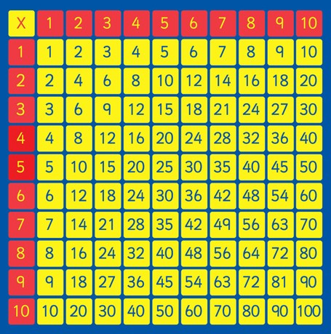  Maths  Practise your 3, 4 and 8 times tables: | Maths  Complete the maths activities on Google classroom.   | Art  Create a model of an artefact that may have been used during the stone age period.  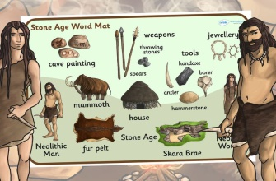 | Science:  Next term you will be learning about living things and their habitats. Research an animal and find out about its food chain.  Can you find out what the terms  producers, predators and prey mean?  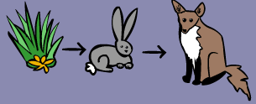
History:  Next term you will be learning about the stone age.  Visit the Library / use the internet to research the Stone Age and create a fact file about it. Include key words such as:  - Homo sapiens  - Flint  - BC  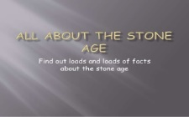  - Hunter gatherer  - Nomad  - Neolithic  - Mesolithic | English:  Find a text to read (example: newspaper article, leaflet or a book) and write a book review about it.  Include:  - Book title/author  - Why you like/dislike it  - Would you recommend it?  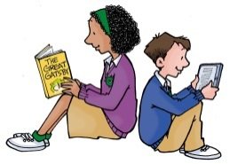 | English  Write an adventure story of your choice.  Make sure include:  - adverbs  - inverted comma’s  - descriptive language  - capital letters/ full stops  - question marks   | RE  Write a prayer of thanks for all of the fantastic memories of Year 3 and your school life so far. Make sure you present your prayer beautifully with lots of illustrations.  

