Cathedral School of St Peter and St John RC Primary
EYFS Long Term Overview 2024-2025
 | Autumn 1  (7 weeks) | Autumn 2  (7 weeks) | Spring 1  (6 weeks) | Spring 2  (7 weeks) | Summer 1  (5 weeks) | Summer 2  (6 weeks)
Driver project | Me and My Community  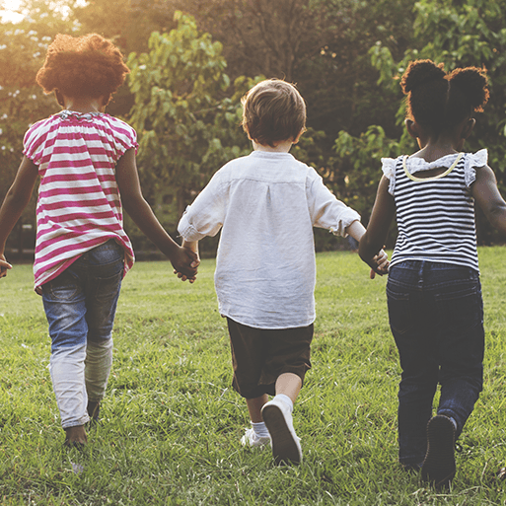 |   Once Upon a Time |   Starry Night |   Dangerous Dinosaurs | 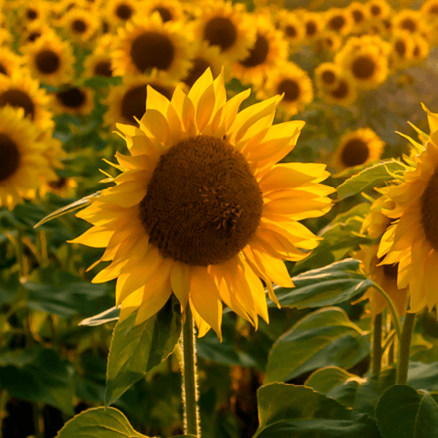  Sunshine and Sunflowers |   Big Wide World
Mini project | Exploring Autumn | Sparkle and Shine | Winter Wonderland | Puddles and Rainbows | Shadows and Reflections | Splash!
Enhancements incl Visits | Looking for the signs of Autumn around the school grounds. | Heaton Park – signs of Autumn  Halloween  Guy Fawkes Night | Looking for signs of winter around the school grounds.  Chinese New Year  Shrove Tuesday  International Women’s Day | Looking for signs of spring around the school grounds.  World Book Day  Mother’s Day | Living Eggs  Caterpillars/ Butterflies  Peel Park Visit | Farm Visit  Fathers Day
Come and See/Caritas Unit | Come and See Theme 1 Domestic Church – Family  Caritas Theme 5 Option for the Poor and Vulnerable  Poetry about Gospel Values | Caritas Theme 3 Solidarity and the Common Good  Come and See Theme 4 Local Church – Community  Come and See Theme 3 Advent - Loving | Come and See Theme 2 Baptism – Belonging  Caritas Theme 2 Family and Community  Judaism | Come and See Theme 8 Reconciliation – Inter-Relating  Come and See Theme 6 – Lent (begins 17th February)  Stations of the Cross (QR Code and Orienteering) | Come and See Theme 5 Eucharist – Relating  Old Testament Stories  Caritas Theme 1 Dignity of the Human Person (links with Come and See Theme 7 Pentecost) | Come and See Theme 7 Pentecost – Serving  World Religions  Come and See Theme 9 Universal Church  Caritas Theme 7 Stewardship – Laudato Si Celebration
Core Texts | Me and My Community  - Five Minutes Peace  - The Lion and The Mouse  - Lost and found  - Enemy Pie  - Collin and Lee, Carrot and Pea  - My Mum  - Superhero Dad  - People Who Help Us  - Once There Where Giants  - The Rainbow Fish  - The Baby’s Catalogue  - Families, Families, Families!  Exploring Autumn  - Leaf Man  - How Many Seeds in a pumpkin?  - Pumpkin Soup  - The Gruffalo  - Stick Man | Once Upon A Time  - Goldilocks and the Three Bears  - Little Red Riding Hood  - There Is No Dragon in This Story  - Princess Daisy and the Dragon and the Nincompoop Knights  - Hansel and Gretel  - Cinderella  - The Three Billy Goats Gruff  - The Three Little Pigs  - Goldilocks and Just the One Bear  - #Goldilocks: A Hashtag Cautionary Tale  - The Princess and the Pea  - Snow White and the Seven Dwarfs  - Aladdin  - Rapunzel  - Beauty and the Beast  - The Worst Princess  Sparkle and Shine  - Little Glow | Starry Night  - Peace at Last  - Whatever Next!  - How to Catch a Star  - The Way Back Home  - Owl Babies  Winter Wonderland  - The Gruffalo’s Child  - The Big Freeze | Dinosaurs  - The Girl and the Dinosaur  - Cave Baby  - Dear Dinosaur  - Dear Dinosaur: T. Rex on Tour  - Dinosaur Roar!  - If I had a dinosaur  - Little Kids First Big Book of Dinosaurs  - Tyrannosaurus Drip  - Creature Features: Dinosaurs  - Prehistoric Mammals  - We're Going on a Bear Hunt  Puddles and Rainbows  - The Colour Monster  - Puddling! | Sunshine and Sunflowers  - Summer is Here!  - My First Book of Garden Bugs  - Sun (Whatever the Weather)  - Errol's Garden  - I can grow a Sunflower  - The Tiny Seed  - The Very Hungry Caterpillar  - The Crunching Munching Caterpillar  - My Butterfly Bouquet  - Jump and Shout!  - The Little Gardener  - Summer  Shadow and Reflections  Little Echo  Through the Magic Mirror  The Foggy Foggy Forest  Little Beaver and The Echo | Big Wide World  - All Are Welcome  - Our World: A First Book of Geography  - Fatou, Fetch the Water  - Don't Spill the Milk!  - Penguin on Holiday  - Walk this World: A celebration of life in a day  - Under the Same Sky  - Catch That Goat!: A Market Day in Nigeria  - David Attenborough: Little People, Big Dreams  - My Granny Went to Market: A Round-the-World Counting Rhyme  - Baby Goes to Market  - Handa's Surprise  - Little Turtle and the Sea  - One Gorilla: A Counting Book  - There's a Rang-Tan in My Bedroom  - Clean Up!  Splash!  The Duck Who Didn't Like Water  - Commotion in the Ocean  - Water (Rise and Shine)
Literacy | Actions to rhymes  Rhyme and rhythm  Listening to, and identifying sounds  Instrumental sounds  Environmental sounds  Prepositions | Learning stories off by heart  Acting out a story  Exploring sounds  Rhyme and rhythm  Voice sounds  Environmental sounds | Rhymes and rhythm  Rhyme and patterns  Links to the senses  Animal sounds  Initial sound recognition (eg. satpin) | Oral re-telling  Acting out a story  Putting sounds/ percussion to a story  Initial sounds recognition/ letter recognition | Initial sounds recognition/ letter recognition  Blending and segmenting sounds | Letter recognition  Blending and segmenting sounds
Links with Science | Use hands on exploration of natural materials.  Explore collections of materials with similar and/or different properties.  Talk about the differences between materials and changes they notice. | Use hands on exploration of natural materials.  Talk about what they see, using a wide vocabulary. | Talk about what they see, using a wide vocabulary.  Explore collections of materials with similar and/or different properties.  Use hands on exploration of natural materials. | Plant seeds and care for growing plants.  Begin to understand the need to respect and care for the natural environment and all living things.  Understand key features of a life cycle of a plant and an animal. | Begin to understand the need to respect and care for the natural environment and all living things. | Begin to understand the need to respect and care for the natural environment and all living things.  Explore how things work.  Explore and talk about different forces they can feel.
Links with Geography | Continue to develop a positive attitudes about the differences between people.  Know that there are different countries in the world and talk about the differences they have experienced or seen in photos.  Begin to make sense of their own life-story  and family’s history | Use all their senses in hands-on exploration of natural materials.  Explore collections of materials with similar and/or different properties.  Talk about what they see, using a wide vocabulary | Use all their senses in hands-on exploration of natural materials.  Explore collections of materials with similar and/or different properties.  Talk about what they see, using a wide vocabulary. | Use all their senses in hands-on exploration of natural materials.  Explore collections of materials with similar and/or different properties.  Talk about what they see, using a wide vocabulary. | Use all their senses in hands-on exploration of natural materials.  Explore collections of materials with similar and/or different properties.  Talk about what they see, using a wide vocabulary. | Continue to develop a positive attitudes about the differences between people.  Show an interest in different occupations.
Links with History  Chronology  Vocabulary related to time  Enquiry  Concepts |  | Advent/Nativity story | Begin to make sense of their own life-story and family’s history. (link with baptism in Religion) | Begin to make sense of their own life-story and family’s history. – children to find out what jobs the adults in their families do. | Understand the key features of the life cycle of a plant and an animal.
Links with Art (Art and Design) | Explore and identify materials freely, in order to develop their ideas about how to use them and what to make.  Develop their own ideas and then decide which materials to use to express them.  Join different materials and explore different textures. | Self portraits  Still life drawings of vegetables to link with harvest time.  Create closed shapes with continuous lines and begin to use these shapes to represent objects.  Draw with increasing complexity and detail,  such as representing a face with a circle and including details.  Show different emotions in their drawings and paintings, like happiness, sadness, fear etc | Explore colour mixing. | Draw with increasing complexity and detail,  such as representing a face with a circle and including details. | Draw with increasing complexity and detail,  such as representing a face with a circle and including details. | Use drawing to represent ideas like movement or loud noises.
Links with Music (Art and Design) | Singing focus – Nursery Rhymes  Listen with increased attention to sounds.  Sing the pitch of a tone sung by another person (pitch match)  Sing the melodic shape (moving melody, such as up and down, down and up) of familiar songs. | Links made with phonics through exploring environmental and instrumental sounds  Children sing songs, make music and dance, and experiment with ways of changing them  Remember entire songs. (nativity) | Children sing songs, make music and dance, and experiment with ways of changing them.  Create their own songs, or improvise a song around one they know. | Children sing songs, make music and dance, and experiment with ways of changing them. | Children sing songs, make music and dance, and experiment with ways of changing them.  Respond to what they have heard, expressing their thoughts and feelings. | Children sing songs, make music and dance, and experiment with ways of changing them.  Play instruments with increasing control to express their feelings and ideas.
This planning acts as an overview to ensure coverage of some of the learning objectives in the EYFS. It should not be viewed in its entirety as the whole curriculum that we offer. Our planning allows for flexibility and will often be enhanced by the children’s interests during a specific topic.
Note: Statements in italics are taken from The New EYFS Development Matters 2020

Maths

https://assets.whiteroseeducation.com/Resources/nursery/Maths%20Yearly%20Overview.pdf?_gl=1*1bweeum*_gcl_au*MTgwODgyNzIyNS4xNzI1MjcyMDUxLjE0MjI0NTQ0MzQuMTcyNTI3MjA3NC4xNzI1MjcyMDc4*_ga*NDM1NDY0OTA5LjE3MjUyNzIwNTg.*_ga_869Y76J73T*MTcyNTI3MjA2MC4xLjEuMTcyNTI3MjEwOC4xMi4wLjA.

