Nursery Curriculum Overview

Curriculum area | Autumn 1 | Autumn 2 | Spring 1 | Spring 2 | Summer 1 | Summer 2
Curriculum area | Nursery Rhymes | Night and day | It’s Cold out there | New Life | What’s in the garden? | People who help us
Literacy  Core Text | Nursery rhymes  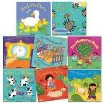 | Owl Babies- Martin  Waddell  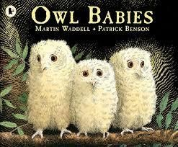 | Here comes Jack Frost by Kazuno Kohara  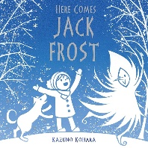 | What the Ladybird Heard by Julia Donaldson  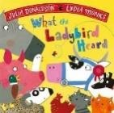 | The Very Hungry  Caterpillar- Eric Carle  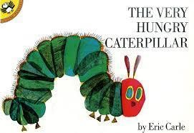 | What do Grown Ups do all day  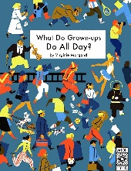
Additional/Supporting Texts  Non-fiction texts and poetry to support as well as these texts. | Traditional Tales/Fairy Tales e.g.  Little Red Riding  Hood  The Ugly Duckling  Hansel and Gretal  The Gingerbread Man  The Colour Monster | Can’t You Sleep Little Bear by Martin Waddell  Whatever Next by Juill Murphy  Night Monkey, Day  Monkey by Julia  Donaldson  Seasonal:  Room on the Broom bu Julia Donaldson  Stick man by Julia Donaldson  Mogs Christmas by  Judith Kerr | Red Sledge – Lita Judge  Various Non Fiction for Winter and Arctic Environments | Jasper’s Beanstalk by Mick Inkpen  Oliver’s Fruit Salad by Vivian French  Planting a Rainbow by Lois Elhert  Titch by Pat Hutchins  The Tiny Seed by Eric  Carle  Teon Seeds by Ruth  Brown  Various Non-fiction texts based on the farm / chicks | Argh Spider  By Lydia Monks  Ben plants a butterfly garden by Kate Perry  Eric Carle books  Incy Wincy Spider by Keith Chapman  The Very Greedy Bee by Steve Smallman The Crunching,  Munching Caterpillar by Sheridan Cain  Various Non-fiction books on growing  plants/minibeast | Mog and the Vee E Tee  By Judith Kerr  Emergency by Margaret Mayo  The Jolly Postman by Allen Alberg  After the Storm by Nick Butterworth  Mrs Vole the Vet by Allan  Ahlberg  Tough Truck Rescue by Kate Hayley  Various Non-Fiction books based on People who help us
Communication and Language  Rhymes | Core rhymes:  Round and round the garden  Wind the bobbin up  Pat-a-cake  Hickory Dickory Dock  Ring-a-ring a rose  Share rhyme with parents for home learning. | Revisit previous rhymes to build up automatic recall.  Introduce new rhymes:  Twinkle Twinkle  Jack and Jill | Revisit previous rhymes to build up automatic recall.  Introduce new rhymes:  Row Row Row your boat  Hey Diddle Diddle  Down at the Station  A Sailor went to Sea | Revisit previous rhymes to build up automatic recall.  Introduce new rhymes:  Baa Baa Black Sheep  Mary Mary Quite Contray Humpty Dumpty | Revisit previous rhymes to build up automatic recall.  Introduce new rhymes:  Incy Wincy Spider  There’s a tiny Caterpillar | Revisit previous rhymes to build up automatic recall.  Introduce new rhymes:  Miss Polly had a dolly
Phonics | No sounds – focus on Rhyme time  and settling children into your  setting’s routines. | Introduce sounds  s a t p i n m | Introduce sounds  d g o c k e | Introduce sounds  u r h b f l | Introduce sounds  j v w y z qu ch | Introduce sounds  ck x sh th ng nk
Listening and Attention | Pay attention to one thing at a time  Listen 1:1 to develop independence within daily routine  Participate in short multi-sensory group time  Enjoy listening to stories with illustrations, props, sounds  Recall key events/name characters  Begin to join in with refrains and actions  Follow simple one part instructions  Understand simple questions, who, what, where |  | Enjoy listening to longer stories and remember much of what happens  Begin to shift attention from one thing to another  Begin to understand and follow a two part instruction  Begin to show an understanding of some prepositions  Begin to listen to others in a small group  Understand why questions |  | Enjoy listening to longer stories with increased attention and can remember much of what happens  Shift attention from one thing to another when needed  Understand and follow a two part instruction  Understand and respond confidently to simple why questions  Show an understanding of some prepositions  Listen to others in a group
Comprehension | Pay attention and respond to pictures or the words  Repeat words and phrases from familiar stories  Make comments about the book | Engage in stories | Engage in stories and talk about them | Engage in stories, begin to have conversation about them | Engage in stories, begin to have conversation about them, begin to use vocab from the  book to talk about  them | Have conversation about them, begin to use vocab from the book to talk about them  Begin to join in with repeated refrains
Speaking | Make themselves understood Start to say how they are feeling, using words and actions  Join in with register Children talking about experiences that are familiar to them.  Exploring and making sounds. Modelling language/topic related  vocab to children Ask questions  Ask adults for help. | Use simple/common vocab to describe themselves and personal experiences Speak in 2/3 words sentences or simple phrases  Start conversations with adults or friends Respond to others in play.  Talk about favourite stories/rhymes. | Be able to express a point of view  Use talk to organise themselves and their play Re-enact a story with story language. | Begin to introduce and use ‘scientific’ and ‘topic’ based vocab  Use longer sentences of  4-6 words  Start conversations with adults or friends and continue it for many turns  Build up rhyming knowledge.  Become more outgoing in new situations. | Be able to express a point of view and to debate when they disagree with an adult or friend using words as well as actions Play rhyming and alliteration games. | Use a wider range of topic related vocab Sing a large repertoire of songs  Join sentences up with because or and
Writing | *Sometimes giving meaning to marks  *Developing preferences when mark making | 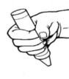  Cylindrical grasp (whole hand)    Prewriting shapes | 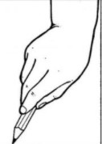  Digital grasp  Prewriting shapes | 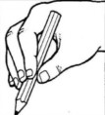  Modified tripod grasp    Prewriting shapes | Modified tripod grasp    Prewriting shapes | 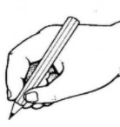  Tripod grasp  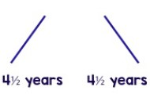  Prewriting shapes
 | WRITING PROGRESSION  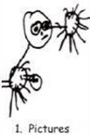 | WRITING  PROGRESSION  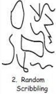 | WRITING PROGRESSION  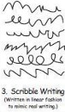 | WRITING  PROGRESSION  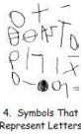 | WRITING  PROGRESSION  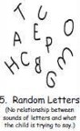 | WRITING  PROGRESSION  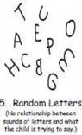
 | Add some marks to their drawings which they give meaning to  Make marks on pictures to represent their name  Begin to attempt to write name with some recognisable letters (e.g first letter of name)  Begin to understand that their own marks represent meaning  Point to marks  Talk about the marks made  Label marks |  | Begin to use some print/letter knowledge in writing  Start to represent symbols and shapes – lines an circles  Begin to form recognisable letters  Mark make with left to right directionality and top to bottom directionality and point this out  Ascribe meaning to marks made  Begin to engage in purposeful mark making  Attempt to write name, using name card, with some recognisable letters, some correctly formed. |  | Use knowledge of print/letters in writing  Form recognisable letters  Begin to match some letters to phonemes e.g. m for mummy  Engage in purposeful early writing  Write name from memory with correct formation.
Maths | Comparison 1  More than, fewer than, same  SSM 1  Explore and build with shapes  Pattern 1  Explore repeats  Counting 1  Hear and say number names | Counting 2  Begin to order number names  Subitising 1  I see 1, 2, 3  Pattern 2  Join in with repeats  SSM 2  Explore position and space | Subitising 2  Show me 1, 2, 3  Counting 3  Move and label 1, 2, 3  SSM 3  Explore position and routes  Pattern 3  Explore patterns | Counting 4  Take and give 1,2, 3,  SSM 4  Match, talk, push, pull  Subitising 3  Talk about dots  Comparison 2  Compare and sort collections | Pattern 4  Lead on own repeats  SSM5  Start to puzzle  Pattern 5  Making patterns together  Subitising 4  Make games and actions | Counting 5  Show me 5  Pattern 6  Show me 5  Counting 6  Stop at 1,2,3,4,5  Comparison 3  Match, sort, compare
Religion
Understanding the World (UW)
Science (UW) | All about Me  My body  Autumn  Children will use all their senses in hands on exploration of natural materials.  Explore collections of materials with similar and/or different properties. | Day and Night  Seasons-Winter Difference between day and night  Animals that hibernate  Water freezing | Winter –  Ice  Children will use all their senses in hands on exploration of natural materials.  With support the children use magnifying glasses to make observations. | Seasons- Spring  Plant seeds and care for growing plants.  Understand the key features of the life cycle of a  plant and an animal.  Understand the key features of the life cycle of a  plant and an animal. (chicks)  Begin to understand the need to respect and care  for the natural environment and all living things. | Mini beasts  Observe life cycle of a butterfly in Nursery Explore mini beasts and outdoors.  With support the children use magnifying glasses to make observations.  Seasons- Summer  Understand the key features of the life cycle of a  plant and an animal.  (butterfly)
Geography (UW) | Locational Knowledge  Continue to develop a positive attitude about the differences between people.  (NC Locational Knowledge) | The Natural World  Changes in Autumn  Autumn walk  Our school environment  Explore the natural world around us  (NC Place knowledge  Locational Knowledge) | The Natural World  Understand there are different countries in the world – talk about the differences I have experienced or see in photographs.  (NC Place knowledge  Locational Knowledge) | The Natural World  Changes in Spring  Spring walk- Exploring the natural world. Changes in the environment  Show care and concern for living things and the environment.  (NC Place knowledge  Locational Knowledge)  (NC Human and physical) | Maps linked to ‘We’re going on a bear hunt’  We’re going on a bug hunt  Physical features in story book/our environment (grass, mud, cave etc)  (NC Geographical skills and field work) | Show an interest in different occupations  (NC Human and Physical)
History (UW) | Past and Present My family and friends  Begin to make sense of their own family | People, Culture and  Communities Experiences of celebrations in my  home/family/community. | Past and Present I remember when…  Link to seasonal changes | Past and Present  Passing of time linked to  growth of chicks. | Past and Present  Passing of time linked to  growth and planting. | People, Culture and  Communities  Experiences of people who help us  .  Begin to make sense of their own life story and family history – children to find out what jobs the adults in their families do.  Past and Present  I remember when…  (memories from  Nursery)
Nursery Curriculum Overview

 | Expressive Arts and Design (EAD)
Art (EAD) | Observational  Drawings of ourselves.  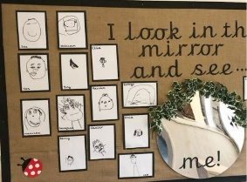  Create closed shapes with continuous lines and  begin to use these shapes to represent objects. | Observational  Drawings in Nature  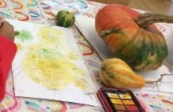  Artist Andy Goldsworthy  Creating using different media  Bonfire night/Diwali  (fireworks)  Use drawing to represent ideas like movement  or loud noises. | Explore colour and colour mixing.  Kandinsky concentric circles  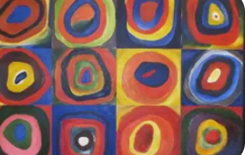  Hot/cold colours  Adding black/white - tones/tints.  ‘Cold paintings’ | Observational  Drawings – Farm animals  Create closed shapes with continuous lines and  begin to use these shapes to represent objects. | Henri Matisse – The Snail  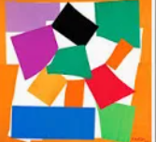  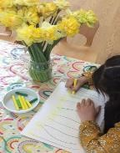  Art  Inspired by our  Gardens  Georgia O’Keefe -poppies  Van Gogh – Sunflowers | Art Inspired by People Who Help Us  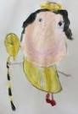
Design &  Technology  (EAD) | Creating with Materials Manipulate and play with  different materials | Creating with Materials  Explore different materials using their  senses | Creating with Materials Use recycled materials to make models of cars | Creating with Materials Use different materials to make flowers Begin to use tools | Creating with Materials Use different materials to make flowers Begin to use tools. | Creating with Materials Use different materials to make a bag for a doctor
Music  (EAD) | Nursery rhymes Joining in with common nursery rhymes | Songs and rhymes Joining in with common songs and rhymes Exploring instruments | Songs and rhymes Joining in with common songs and rhymes Exploring instruments | Sing familiar songs  Sing full songs and join in with common songs and rhymes | Sing familiar songs  Sing full songs  Express thoughts and feelings about songs | Improvise songs around ones they know Sing full songs and improvise
 | Other Areas
Computing | In Nursery children have opportunities to access ICT equipment during continuous provision. During this time children are taught how to handle and use the equipment safely.
Online safety
P.E. (PD) | Physical Development  In Nursery children’s gross motor skills are developed through using the outdoor areas and equipment (tough terrain) and through movement and dance. Basic skills are developed such as, throwing, catching, jumping, hopping, running etc.  Children are given opportunities to use a variety of tools and equipment to help develop their fine motor skills.

PSED  Gospel / British Values  Think Equal Programme | Respect- We value respect by showing good behaviour and polite  manners  Responsibility- We value our responsibility within our community | Kindness- We value kindness as it helps to build friendships Diversity- We value diversity by respecting everyone’s differences | Loyalty- We value loyalty because it means we can trust and depend on each other  Team work- We value team work as together we learn | Honesty- We value honesty by always telling the truth and taking responsibility for our actions  Forgiveness- We value forgiveness as it shows  strength of character | Effort- We value effort as it shows our  determination to succeed Determination- We value determination so we can tackle difficulties in school and in life | Courage- We value courage as taking risks helps us to become confident people
Curriculum Enhancements |  |  | Airport – watch planes  Transport museum | Farm visit  Eggs/chicks | Order Butterflies | Professional visitors – talk about their jobs
Key Events | Transitions – getting to know new friends  Birthdays – when are they?  Harvest  Black History month | World Nursery rhyme week  Halloween  Bonfire Night  Remembrance day  Diwali  Advent  Christmas | Chinese New Year  Valentine’s Day  Shrove Tuesday  Ash Wednesday | Fair Trade Fortnight  Lent  Mother’s Day  World Book Day  Easter | St George’s Day  Eid | Father’s day  Transition day
Parental Engagement Opportunities | Transition Visits  Share weekly rhyme sheet/video (LW) | World Nursery Rhyme week  Library book share set up  Nativity | Any parents with cultural background to support key events |  |  | Parent visitors – talk about their jobs  Sports Day

