 | Autumn 1  (8 weeks) | Autumn 2  (7 weeks) |  |  |  |  | Spring 1  (6 weeks) |  |  |  | Spring 2  (5 weeks/3 days) |  |  |  | Summer 1  (6 weeks) |  |  |  |  |  |  | Summer 2  (6 weeks)
Driver project | Lets Explore  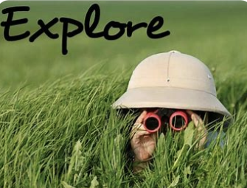 | Marvellous Machines   |  |  |  |  | Long Ago  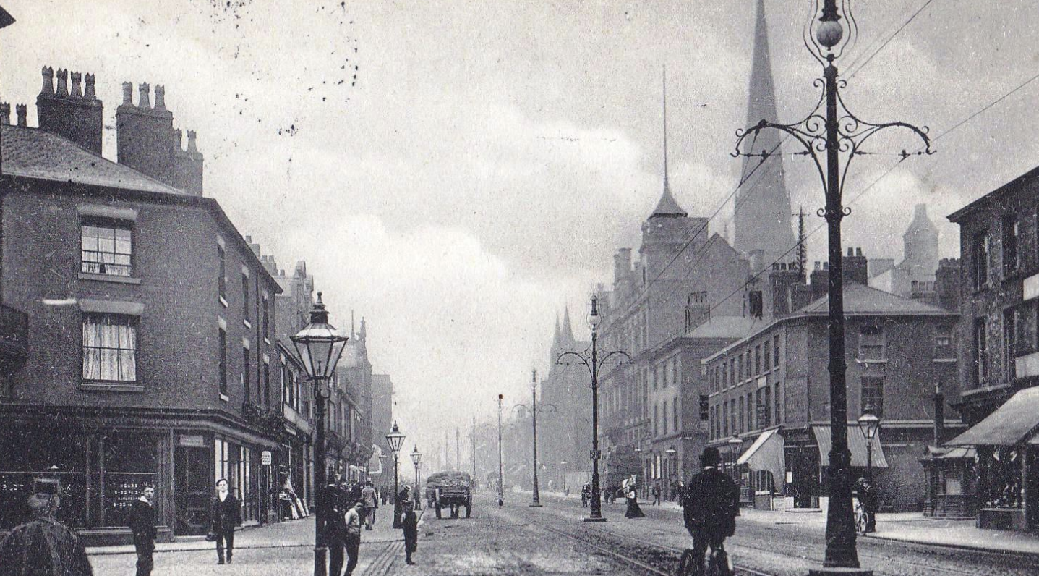 |  |  |  | Ready Steady Grow  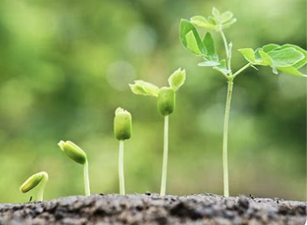 |  |  |  | Animal Safari  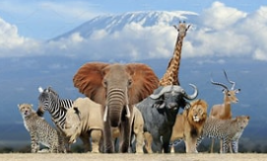 |  |  |  |  |  |  | On the Beach  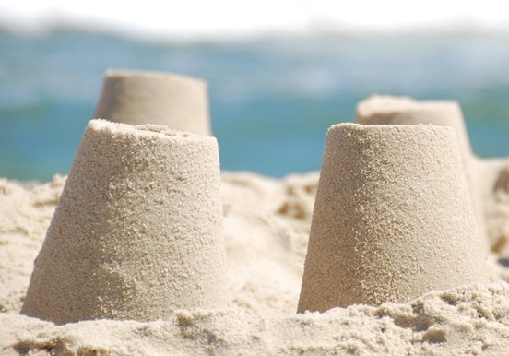
Mini project | Build it up  Signs of Autumn  Black History Month: Mae Jemison  Harvest celebrations. | Puppets and Pop ups |  |  |  |  | Stories and Rhymes  Signs of Winter |  |  |  | Signs of Spring |  |  |  | Creep, Crawl and Wriggle  Signs of Summer |  |  |  |  |  |  | Move it |  |  |  |  |  | Moving on
Enrichment | Exploring our school grounds.  Explore our local area National fitness day:24/09  National Recycling week: 22nd-28th September  European Day of Languages: 26/09  World food day: 16/10 | Visit to Peel Park  Use electrical appliances to cook, such as vegetable soup, bread and toast.  Remembrance Day: 11/11 |  |  |  |  | Visit to Salford Museum  Chinese New Year 17th February- 3rd March: Year of the Horse.  Shrove Tuesday 17th February |  |  |  | Visit to RHS Garden centre  World Book day 5th March  Living eggs FAIRTRADE FORTNIGHT  2nd – 15th March  International Women’s Day: 9/3  Art Week: 16/03  Shakesphere Day: 23/03 |  |  |  | Peel park visit  Caterpillars  Earth Day: 22/04 |  |  |  |  |  |  | Seaside visit: Southport
Texts | - We’re going on a Bear Hunt: Michael Rosen.  - Where the wild Things Are: Maurice Sendak  - In Every House on Every Street:Jess Hitchman.  - Mr Grumpys outing: John Burningham.  - The Great Explorer: Chris Judge  - What to do with a box: Jane Yolen  - Selection of non-fiction books.  - Poetry books. | - Rosie Revere, Engineer: Andrea Beaty.  - The Most Magnificent thing: Ashley Spears  - No-Bot the Robot with no bottom.  - Selection of non-fiction books.  - Poetry books. |  |  |  |  | - Rosie’s Hat: Julia Donaldson.  - The growing story: Ruth Krauss.  - Coming to England: Floella Benjamin.  - Major Glad, Major Dizzy: Jan Oke.  - The snow beast- Chris Judge.  - Selection of non-fiction books.  - Poetry books. |  |  |  | - Jack and the beanstalk  - Handas suprize: Eileen Brown  - Rosie’s walk: Pat Hutchins.  - The Extraordinary Gardener:Sam Boughton  - Tad: Benji Davies  - Selection of non-fiction books.  - Poetry books. |  |  |  | - The Lion inside: Rachel Bright.  - Little Red and The Very Hungry Lion: Alex T. Smith  - Omar, the bees and me: Helen Mortimer and Katie Cottle.  - Snail Trail: Ruth Brown  - The Very Hungry Caterpillar: Eryk Carle.  - Selection of non-fiction books.  - Poetry books.. |  |  |  |  |  |  | - The Sea Saw: Tom Percival.  - Who’s hiding at the seaside: Kathgerine McEwen  - Somebody swallowed Stanley: Sarah Roberts.  - Come away from the water, Shirley: John Burningham.  - What Makes Me a Me: Ben Faulks  - Say goodbye…Say hello: Cori Doerrfeld.  - Up and Down: Oliver Jeffers.  - Selection of non-fiction books.  - Poetry books.
Literacy | - To orally segment and blend words.  - Rhyme and rhythm  - To recognise and apply reading the first 20 phase 2 phonic sounds: s, a, t, p , i, n, m, d, g, o, c, k, ck, e, u, r, r, h, b, f, l.  - To read and write tricky words: is, I, the.  - Exploring the letters in their names  - Writing their own name  - Oral re-telling of stories.  Simple repetitive refrains | - Learn songs and rhymes by heart  - To recognise and apply phase 2 phonics sounds (continue Autumn 1):: ff, ll, ss, j, v, w, x, y, z, zz, qu, ch, sh, th, ng, nk.  - Words with-s /s/ added at the end (hats, sits)  - Words ending in s /z/ (his) and with -s /z/ at the end (bags).  - Tricky words put, pull, full, as, go, no, to, into, she, push, he, of, we, me, be.  - Writing cvc (c: consonant, v:vowel) words  - Blending for reading  - Segmenting for spelling  - Writing for different purposes- shopping lists, wanted posters. |  |  |  |  | - Learn songs and rhymes by heart  - Phase 3 phonics Grapheme/phoneme correspondence: ai, ee, igh, oa, oo, oo, ar, or, ur, ow, oi, ear, air, er.  - Words with double letters: dd, mm, tt, bb, rr, gg, pp.  - Longer words.  - Tricky words: was, you, they, my, by, all, are, sure, pure.  - Learning the alphabet  - …letter names  - Writing uppercase and lowercase letters  - Segmenting for spelling  - Begin to write simple captions.  - To write labels.  - Begin to write simple sentences.  - Read own writing  - Writing for different purposes-diary writing,  - Stories with repeated phrases: |  |  |  | - Phonics Phase 3: Review all taught so far.  - Words with 2 or more diagraphs (2 letters making one sound).  - Words ending in -ing  - Longer words, compound words (two words joined together to make one word).  - Words with s /z/ in the middle.  - Words with -s /s/ /z/ at the end.  - Words with -es /z/ at the end.  - Begin to spell some (tricky words correctly when writing (I, to, the, no, go, into, he, she, we, me).  - Generate questions to ask visitors.  - Practise writing simple sentences.  - Read own writing and check it to see if it makes sense.  - Write a set of simple instructions (planting seeds) |  |  |  | - Phonics phase 4: Short vowel sounds, CVCC, CCVC, CCVCC, CCCVC, CCCVCC.  - Longer words, compound words (two words joined together to make one word).:  - Root words ending in: -ing, -ed /t/, /ed/, -est.  - Tricky words: said, so, have, like, some, come, love, do, were, here, little, says, there, when, what, one, out, today.  - Segmenting to spell  - Write simple sentences  - Read own writing and check it to see if it makes sense  - Use a full stop securely. |  |  |  |  |  |  | Phonics phase 4: Review all taught so far.  Long vowel sounds, CVCC, CCVC, CCCVC, CVC, CCVCC.  - Phase 4 words with -s /s/ at the end.  - Phase 4 words with -s /z/ at the end.  - Phase 4 wordswith -es /z/ at the end.  - Longer words.  - Root words ending in: -ing, -ed /t/, -ed /id/ /ed/, -ed /d/, -er, -est.  - Segmenting to spell  - Write simple sentences  - Read own writing and check it to see if it makes sense.  - Using a capital letter securely.
Maths | NCETM: Mastering in number.  White Rose Maths:  Match, sort and compare.  Talk about measure and patterns.  It’s me, 1,2 ,3. | NCETM: Mastering in number.  White Rose Maths:  Circles and triangles.  1, 2, 3, 4, 5.  Shapes with 4 sides. |  |  |  |  | NCETM: Mastering in number.  White Rose Maths:  Alive in 5.  Mass and capacity.  Growing 6, 7, 8.  Length, height and time. |  |  |  | NCETM: Mastering in number.  White Rose Maths:  Length, height and time.  Building 9 and 10.  Explore 3D shapes |  |  |  | NCETM: Mastering in number.  White Rose Maths:  To 20 and beyond.  How many now?  Manipulate, compose and decompose.  Sharing and grouping |  |  |  |  |  |  | NCETM: Mastering in number.  White Rose Maths:  Visualise, build and map.  Make connections.
UW -Possible links with Science | Understanding of the world ELG: The Natural World. Children at the expected level of development will:  - Explore the natural world around them, making observations and drawing pictures of animals and plants  - Know some similarities and differences between the natural world around them and contrasting environments, drawing on their experiences and what has been read in class.  - Understand some important processes and changes in the natural world around them, including the seasons and changing states of matter
 | - Sort and group materials and resources and talk about how they are similar or different.  - Sensory walk: What can you see, hear, smell, feel?  - Describe what, why and how something was made and compare with others.  - Exploring using torches. | - Use technology to record their work and ideas.  - Develop scientific knowledge through play activities, sharing stories and non-fiction books and discussion.  - Shadow puppets. |  |  |  |  | - To learn about and observe seasonal changes (Winter).  - Develop an understanding of freezing and melting: Read the Snowmans Coat: Brenda and Stuart Naylor.  - Use technology to record their work and ideas. |  |  | - To learn about and observe seasonal changes and (Spring)  - Develop an understanding of what plants need to grow.  - Parts of plant.  - Planting: Observe and record (Diary)  - Where does our food comes from? Food sorting.  - Animals born in spring.  - Life Cycle: Chicken/Hen, frog. |  |  |  |  |  | - Observe and draw pictures of animals and plants.  - Learn about common features of Mammals, Reptiles and birds.  - Carnivores, Herbivores and Omnivores.  - To learn about and observe seasonal changes (Summer).  - Develop an understanding of what we need to stay safe during the summer months.  - Investigate materials: Water resistant/absorbant.  - Liffe Cycle: Caterpillar.  - Bee investigation. |  |  |  |  |  |  | - Floating and sinking.  - Healthy body (importance of physical exercise).  - Shadows.  - Bouncing balls investigation.
UW- Links with History | Understanding the World ELG: Past and Present Children at the expected level of development will:  - Talk about the lives of the people around them and their roles in society;  - Know some similarities and differences between things in the past and now, drawing on their experiences and what has been read in class;  - Understand the past through settings, characters and events encountered in books read in class and storytelling.
 | - Share stories and talk about significant people who lived in the past. |  | - Compare machines of the past and present and how inventions and technology have impacted on our lives.  - Linking to our visit from a paediatric doctor, we will explore the machines used in a hospital and the people who operate them.  - Learn about how machines work: electricity, battery, manual.  - To learn that digital technology is used in all parts of everyday life. Some technology is used to communicate with others.  - Learn about online safety, and what they would do if they saw something online that made them sad, scared or worried.  - Use iPad to take photographs, record sounds and videos.  - Explore Digital technology: Calculators, scales. Recording equipment.  - Digital Art: Jackson Pollack style. |  |  |  | - Discuss how the local environment has changed over time using photographs and first-hand experiences.  - Explore and talk about important events in the school or locality’s history.  - Share fiction and non-fiction stories that show how people lived in the past to now.  - Traditional tales such as the elves and the shoemaker.  - Chronology: Ordering days of the week, months of the year, seasons, routines.  - Use different apparatus to measure time.  - Black and White photographs.  - How have they grown and what they can do now that they couldn’t before?  - Sequence familiar events.  - Family history and traditions.  - How things have changed: School days, shopping, clothes, toys. |  |  |  |  | - Farming in the past.  - Put familiar events in chronological order, using pictures and discussion: Draw on experiences such as RHS garden centre and, what has been read in class Remembering our experience at RHS  - Shakesphere Day 23rd March |  |  |  |  | - Talk about the different occupations that familiar adults and members of their community have (vet).  - Animals that help us (dog for disabilities/police/rescue). |  |  |  |  |  |  | - Memories of family holidays and picnic in the park.  - Holidays in the past  - Talk about the different occupations that familiar adults and members of their community have (coastguard).
UW- Links with Geography | Understanding of the World ELG: People, Culture and Communities. Children at the expected level of development will:  - Describe their immediate environment using knowledge from observation, discussion, stories, non-fiction texts and maps;  - Know some similarities and differences between different religious and cultural communities in this country, drawing on their experiences and what has been read in class;  - Explain some similarities and differences between life in this country and life in other countries, drawing on knowledge from stories, non-fiction texts and – when appropriate – maps.
 | - Exploring our school environment  - Exploring our local environment.  - What changes have there been in the local area?  - Taking photographs  - Make and use simple maps in their play to represent places and journeys, real and imagined.  - Talk about stories and make connections with events in their own lives, what do they see on their way to school? What places have they visited?  - Understand some important processes and changes in the natural world around them, including the seasons and changing states of matter. |  |  |  | - Rememberence Day 11th November |  |  | - Geographical change: Scenes from the past.  - To look after the immediate environment  - Show an awareness of the similarities and differences between people in different communities and groups from around the world: Easter and Holi, festival of colours (Celebrated by Hindus) |  |  |  |  |  | - Input simple instructions to make technical toys operate.  - Geographical data collected through fieldwork (exploring plants and animals in the local environment)  - Make and use simple maps in their play to represent places and journeys, real and imagined. |  |  |  | - Use software to research the care of animals.  - Represent journeys.  - Animals around the world and in our local area.  - Hot and cold countries: Habitats.  - Looking after our environment and living things.  - Compare the way people live around the world.  - Earth Day 22nd April |  |  |  |  |  |  | - What can you do at the beach?  - Compare environments.  - Habitats (who lives on th seashore?)  - Oceans and seas around the world (Coral Reef, Polar regions).  - Care for the environment and living things  - Safety at the seaside/at sea.  - Looking at our year in Reception..  - Sporting heros
EAD- links with Art and Design | Expressive Arts and Design ELG: Creating with Materials. Children at the expected level of development will:  - Safely use and explore a variety of materials, tools and techniques, experimenting with colour, design, texture, form and function;  - Share their creations, explaining the process they have used.  - Make use of props and materials when role playing characters in narratives and stories.
 | - Painting from observation and imagination using water colours.  - Create a feely box using different materials.  - Take part in imaginative, creative and sensory play activities.  - Develop storylines in their pretend play. Invent, adapt and recount narratives and stories with peers and their teacher: Interactive displays of core texts.  - Use everyday products, stories, pictures, interests and experiences to inspire their creations: creating houses of all sizes for the 3 little pigs, small world figures and minibeasts. |  |  |  |  | - Tinkering with machines (no longer working), looking at how they are designed.  - Exploring how machines help us? (toaster, microwave, hospital equipment)  - What machines need electricity.  - Making vehicles using clay, boxes, wheels and axles.  - Make puppets to use in the small world.  - Digital Art inspired by Jackson Pollack.  - Construct simple structures and models using a range of materials.  - Imaginative play activities using props.  - Paper bag/stick puppets. |  |  | - Perform songs, rhymes, poems and stories with others, and – when appropriate – try to move in time with music.  - Create art using parts from machines, nuts, bolts, screws.  - Explore, build and play with a range of resources and construction kits with wheels and axles.  - Make peg dolls.  - Explore the artwork Leonardo da Vinci (Portrait: Mona Lisa): Create self-portraits using charcoal.  - Colour mixing including black and white to make different shades of grey.  - Add wheels and axles to construction area (Horse and carts). |  |  |  |  | - Still life drawings using pastels.  - Printing.  - Artist Giuseppe Arcimboldo: Face of fruit.  - Design and make musical instruments.  - Create food labels. |  |  |  |  |  | - Weaving, pattern making.  - Collages: Favourite animals.  - Artist Matisse: Snail.  - Butterfly prints.  - Art Week: |  |  |  |  |  |  | - Artist Monet The beach.  - Seaside landscape.  - Artist Matisse:: ‘Les Beles de la Mer’- ‘The beast of the sea’  - Seashore Mural.  - Transitional art using shells, pebbles, driftwood, sand.  - Boat/raft building.  - Fabric painting.  - People drawing.
EAD - links with Music | ELG: Being Imaginative and Expressive. Children at the expected level of development will:  - Invent, adapt, recount narratives and stories with peers and their teacher.  - Sing a range of well-known nursery rhymes and songs.  - Perform songs, rhymes, poems and stories with others, and – when appropriate – try to move in time with music.
 | - Listen to a variety of music and sounds (under the sea, rainforest, at the seaside).  - Song: We’re going on a bear hunt. |  |  |  | - Explore playing a variety of percussion instruments.  - Add sound effects to stories. |  | - Dance to music, such as pop, country dance, waltz, tango and rock and roll  - Sing a range classic nursery rhymes.  - Nursery rhyme presentation.  - Name the tune. |  |  |  |  |  | - Learn songs:  Oats and beans and barley grow.  Dingle Dangle Scarecrow.  Old MacDonald had a farm: Props.  The farmers in his Den.  - Listen to the Spring music by Vivaldi. |  |  |  |  |  |  |  | - Learn songs:  The bear went over the mountain.  The Animal Fair.  The carnival of the animals.  - Listen to the music ‘Flight of the Bumblebee’ by Nikolai Rimsky-Korsakov. |  |  |  |  |  | - Learn songs:  I do like to be beside the seaside.  A sailor went to sea.  Bobby Shafto’s gone to sea.  She sells seashells.  - Listen to the music ‘The Sailors Hornpipe by the Orchestral College.  - Music and movement: Dance like a sailor/pirate.
Religion | To Know You More Clearly: Creation and Covenant  The words and actions of the Sign of the Cross. God created the world and said, ‘Indeed it is very good’.  (Genesis 1:31)  The whole of creation shows God’s love for us.  (Laudato Si’ 84-88)  St Francis of Assisi ‘Make me a channel of your peace’  Caritas – Dignity of the Human Person  Caritas – Option for the Poor and Vulnerable  Rosh Hoshannah  International Day of Charity (Links to Pilgrims of hope: 5th September  International Day of Peace: 21st September  Yom Kippur: 1st October  Diwali: 20th October |  |  | To Know You More Clearly: Prophecy and Promise  The Annunciation (Lk 1:26-31, 38) The Nativity  (Lk 2:4-7)  The Shepherds visit the manger  (Lk 2:28-30)  Baptism  Caritas- Solidarity and the common good.  Research of a female Saint: Saint  Interfaith Week: 10th November  Jubilee of hope: Pilgrims Celebration Day  Hannukah: 15th December |  |  | To Know You More Clearly: From Galilee to Jerusalem  The Visit of the Magi (Matt 2:1-12) What?  Jesus blesses the little children  (Mk 10:13-16) How?  Feeding of 5000 (Jn 6:1-14)  Caritas – Family and Communities  Epiphany  Shrove Tuesday: 17/02  Ash Wednesday: 18/02  Other Religions: Judaism 17/02-18/03  Ramadan: 17/02- 18/03 |  |  |  |  |  | To Know You More Clearly: From Desert to Garden  A simplified version of key events of Holy Week especially Good Friday and Easter Sunday (to  recognise key events).  The great commandment  (Lk 10:25-28)  Lent  Alleluia Parade  Stations of the Cross  Big Lent Walk  Holi: 4/03  Eid al Fitr: 19/03  St Oskar Romero  Passover: 1/04-9/04  Palm Sunday: 29/03  Maundy Thursday 2/04 |  |  |  |  |  | To Know You More Clearly: To the Ends of the Earth  Story of Pentecost (simple telling).  The early Christian community  (Acts 2:42-47)  Eucharist  Vaisakhi: 14/04 |  |  |  |  |  |  | To Know You More Clearly: Dialogue and Encounter  DIALOGUE  Friends of Jesus: Hear a simple life of St Peter  and St Paul, friends of  Jesus (link to St Charles’  Feast Day)  Ask a local parishioner to talk about their faith and why it matters to them to be a friend of Jesus. Explore a range of pictures of Jesus from a non-European tradition  Caritas – Stewardship Laudato Si celebration

This planning acts as an overview to ensure coverage of some of the learning objectives in the EYFS. It should not be viewed in its entirety as the whole curriculum that we offer. Our planning allows for flexibility and will often be enhanced by the children’s interests during a specific topic.

