

Autumn Term in Year 3




Science
In Maths we develop their natural curiosity and enhance their resilience, so they become ‘deep thinkers’. We foster positive attitudes to learning as we believe all children can achieve in mathematics.
This term we will focus on three main areas of maths:

Place Value: With a focus on numbers to 1000, recognising the value of each digit in three-digit numbers and being able to find 10 or 100 more or less than a given number.

Addition and Subtraction: Building on place value, we will learn more formal methods for recording but also mental strategies and the use of inverse operations to check answers.

Multiplication and Division: We will learn to write and calculate mathematical statements for multiplication and division using the multiplication tables that they know, including for 2-digit numbers times 1-digit numbers, using mental and progressing to formal written methods.

Maths
English

Through the use of high-quality texts, which your children will enjoy and be enthusiastic to share, we will develop their love of reading, widen their vocabulary, developing speaking, listening, reading and writing skills for the real world.
Our core texts for the Autumn term will be:

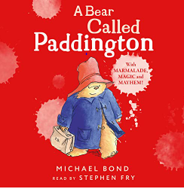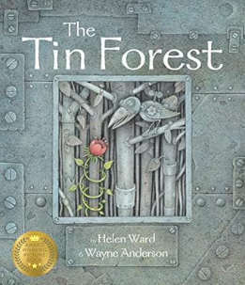

We will also develop understanding of a range of non-fiction reading and writing, including information leaflets about key cities in England and their landmarks.

There will be a key focus on spelling and grammar following on from the phonics learned in Key Stage 1.

In Year 3 your child will:
- Understand how to spell words with a variety of prefixes and suffixes
- Use a wider range of connectives (when, before after, while, so, because)
- Start to use inverted commas to punctuate speech
- Create settings, characters, and plots in narratives.
- Use bullet points and sub-headings
- Assess and improve their writing

The more vocabulary your child hears, the more they will be able to use. We encourage them to read a range of genres independently but also encourage you to continue to share stories with them too.

This term, we will be studying:

Animals, including humans: We will learn to identify that animals, including humans, need the right types and amount of nutrition, and that they cannot make their own food; they get nutrition from what they eat. We will also identify that humans and some other animals have skeletons and muscles for support, protection and movement

Working scientifically: set up practical enquiries / fair tests; make observations; take measurements; gather, record, classify, present, record, report data and findings in a variety of ways; use results to draw conclusions; make predictions; suggest improvements.

.


IMPORTANT POINTS:

Homework is given every Friday, to be returned on Tuesday.
Your child is expected to read every night and be able to talk about what they have read.
Times tables, number facts and spellings should be practiced regularly.
This term, our Religion topic is Domestic Church – Family.
In this topic we explore how God is present in every home. This is expressed in the love that binds the family together within the home through good times and bad times.
We will explore God’s dream for every family and the promises made at Baptism and learn about different saints who show people what God is like.

Religion




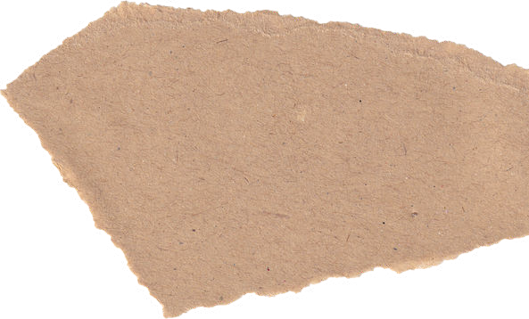

Through the Ages
This project teaches children about British prehistory from the Stone Age to the Iron Age, including changes to people and lifestyle caused by ingenuity, invention and technological advancement.
We will look at historical concepts such as continuity and change and being to place periods and events in chronological order.
We will use historical evidence and artefacts to explore and interpret facts.
We will look at key human features of the period -from settlements and land use, trade, and use of natural resources – this will link to our learning in Geography.
History
DT

Geography
One Planet – Our World.
This essential skills and knowledge project teaches children to locate countries and cities, and use grid references, compass points and latitude and longitude. They learn about the layers of the Earth and plate tectonics and discover the five major climate zones. They learn about significant places in the United Kingdom and carry out fieldwork to discover how land is used in the locality.
Cook Well, Eat Well
This project teaches children about food groups and the Eatwell guide. They learn about methods of cooking and explore these by cooking potatoes and ratatouille. The children choose and make a taco filling according to specific design criteria.

Sport

PE is every Tuesday.
Sessions are led by Mr Finch (Salford Community Leisure), and focus on specific skills such as running, jumping, throwing, and catching; play competitive games; attack and defend; developing flexibility, strength, technique, control, and balance.
This term is Basketball and Football

Your child must have a full PE kit in school each Wednesday. This is a plain white T-shirt, black shorts and a pair of pumps or trainers.

Computing
We start each Year with a focus on staying safe online. We discuss acceptable use and respecting ourselves and others.
Digital Literacy – exploring search engines and using them to solve puzzles and challenges while improving keyboard skills.
Computer Science – Using Scratch Jr children create coding blocks to make a game. They will learn the importance of critical thinking, problem solving and debugging.
Information Technology – Through the use of Virtual Reality (VR) apps they will explore new environments.

Music

Improvise and compose music for a range of purposes.
Listen with attention to detail and recall sounds; use and understand musical notation.
Appraise - appreciate and understand a wide range of high-quality live and recorded music; exploring the history of music.

Contrast and Compliment
This project teaches children about colour theory by studying the colour wheel and colour mixing. It includes an exploration of tertiary colours, warm and cool colours, complementary colours,
Prehistoric Pots
This project teaches children about Bell Beaker pottery. It allows the children to explore different clay techniques, which they use to make and decorate a Bell Beaker-style pot.
Art

