Reception Class Newsletter Autumn 2022

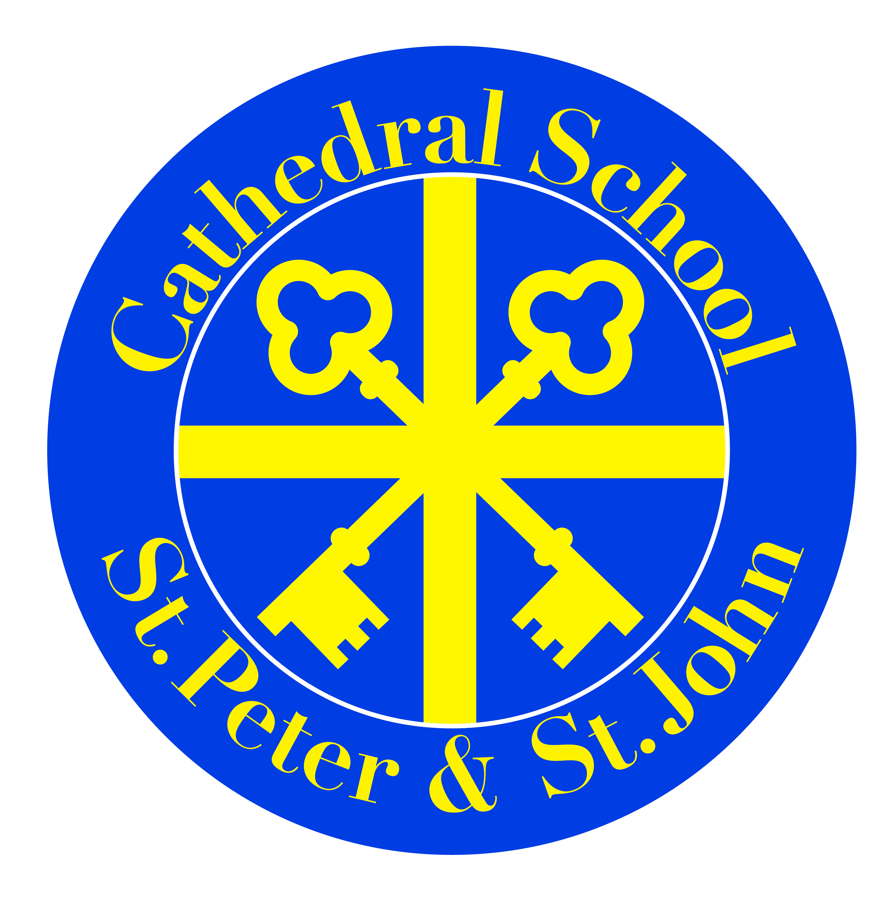

Welcome back to school and an extra special welcome to the new members of Reception Class! It is wonderful to see the children so settled and enthusiastic. They really are a credit to you!
We have a busy half term ahead, with lots to learn, explore and discover. Mrs Hamer, Mrs Culkin and Mrs Linton will be with you every step of the way on our adventure into the Autumn Term.

Phonics 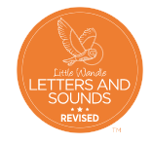
In phonics this half term, Reception will be learning the sounds that letters make. We will also be learning to read the tricky words is, I and the. These words are tricky because we can’t use phonics to sound them out. Your child’s reading book is carefully matched to help them to apply the phonics they have been learning in class. It is very important that children practise reading each night to consolidate what they have been learning in class.
We will also practise writing the letters using helpful rhymes we learn in class to make sure we form the letters correctly.

Understanding of the World

This term, Reception will be finding out about the different types of homes we live in. We will talk about who lives in our homes and how each home is unique and special. We will use maps and computer technology to explore some of the different types of homes in our local area. We will also explore our local area on a walk, looking closely at the houses and buildings we see. We will let you know the dates of when this will be. We will also explore the different types of homes people live in around the world and how homes have changed in the past.
Expressive Art and Design

This term, Reception will be applying and developing their design skills by creating different homes for the three little pigs. We will test if our homes are strong and safe enough for the pigs by trying to ‘huff and puff and blow the houses down’, just like the wolf did in the story. This term we will also be enhancing our drawing skills whilst creating self-portraits. We will look closely at the details of our faces to create life-like drawings.

Maths

In maths this term we will be exploring numbers 1 to 10. We will use lots of different ways to show these numbers and find out how these numbers are made from smaller numbers. Noticing numbers and quantities in the environment with your child is a good way to support them in the numeracy development.
We will explore shape, space and measure in creating different homes for the three little pigs. We will manipulate 3D shapes into models and talk about shapes using specific vocabulary such as cube, sphere, largest, tallest, longest and shortest.

Religion

During the Autumn Term, Reception will be exploring what it means to be a part of a family; our family at home, our class family and our school family. We will learn that we are precious to God and that He knows us all. We will be exploring the importance of the names we were given when we were born and our family name.

Later in the half term we will be learning that God loves us all very much and how we can show our love for other people.

Literacy

This term, as part of our ‘Once Upon a Time’ topic, we will be reading some traditional tales focusing on The Gingerbread Man, The Little Red Hen and The Three Little Pigs. We will explore the characters in these stories through role play and using our small world equipment. We will learn about instructional texts through baking bread. We will also read non-fiction texts together as we explore the different types of homes people live in both in our area and in different places around the world.

