Pupil Premium Strategy Statement 2023 – 2024
The Cathedral School of St Peter and St John RC Primary
Growing together in God’s loving family, we support, challenge and inspire to be the best that we can be
Curiosity – Aspiration – Resilience # drivingtosuccess

This statement details our school’s use of pupil premium (and recovery premium for the2022 to 2023 academic year) funding to help improve the attainment of our disadvantaged pupils.

It outlines our pupil premium strategy, how we intend to spend the funding in this academic year and the effect that last year’s spending of pupil premium had within our school.

School Overview

Detail | Data
School name | The Cathedral School of St  Peter and St John RC  Primary
Number of pupils in school | 216
Proportion (%) of pupil premium eligible pupils | 30%
Academic year/years that our current pupil premium strategy plan covers | 2023/24
Date this statement was published | October 2023
Date on which it will be reviewed | January 2024
Statement authorized by | Iain Clarke Chair of Governors
Pupil Premium Lead | Diane Hanley Linda Jordan- Finance
Governor Lead | Iain Clarke COG

Funding Overview

Detail | Amount
Pupil premium funding allocation Sept 2023– March - 2024 | £ 49,708
April 2024 – August 2024 | £ 35,512
Recovery premium funding allocation this academic year | £8,953
Pupil premium funding carried forward from previous years (enter £0 if not applicable) | £47,922
Total budget for this academic year | £142,096

Statement of intent
When making decisions about using Pupil Premium funding it is important to consider the context of the school and the subsequent challenges faced.
This alongside research conducted by the EEF. Common barriers to learning for disadvantaged children can be: less support at home, weak language and communication skills, lack of confidence, more frequent behaviour difficulties and attendance and punctuality issues. There may also be complex family situations that prevent children from flourishing. The challenges are varied and there is no “one size fits all”.

We will ensure that all teaching staff are involved in the analysis of data and identification of pupils, so that they are fully aware of strengths and weaknesses across the school.

Principles

- We ensure that teaching and learning opportunities meet the needs of all the pupils
- We ensure that appropriate provision is made for pupils who belong to vulnerable groups, this includes ensuring that the needs of socially disadvantaged pupils are adequately assessed and addressed
- In making provision for socially disadvantaged pupils, we recognise that not all pupils who receive free school meals will be socially disadvantaged

We also recognise that not all pupils who are socially disadvantaged are registered or qualify for free school meals. We reserve the right to allocate the Pupil Premium funding to support any pupil or groups of pupils the school has legitimately identified as being socially or educationally disadvantaged. By this we mean that some families just do not qualify for free school meals. Some children who live within families where both parents work long hours do not have allocated time to spend with their children at home as they would normally do.
- Pupil premium funding will be allocated following a needs analysis which will identify priority classes, groups or individuals. Limited funding and resources mean that not all children receiving free school meals will be in receipt of pupil premium interventions at one time, however all eligible pupil premium children will receive what they need.

Demography and the school context
- The Cathedral School of St Peter and St John RC Primary is a smaller school for children aged 4-11. There are currently 207 (including Nursery) pupils on roll (National Average 282 without Nursery).
- Most of the children who attend school reside mainly in the local council estates of Lower Broughton – see demographics above.
- Our pupils come from a wide variety of ethnic backgrounds. We currently have at least 31 ethnic groups with 23 different languages. Percentage of ethnic groups in the area = 20% school currently has 58.9%. White British = 33.3
- The school is situated among pockets of affluent communities where the unemployment is lower and the professional workforce is higher than average.
The communities where the families reside read differently.

 | School Area |  | Most Pupils Live |  |  |  |  |  | National  Average  where available | Salford Ellenbrook Worsely Area | Surrey School
 | School Area |  |  | pupils live
Highest paid  Professional workforce | 29% | 13% |  |  |  |  |  |  | 30.4% | 46% | 60%
Lowest paid | 18.1% | 38% |  |  |  |  |  |  | 11.6% | 6.8% | 15.6
Unemployment | 3.4% |  |  |  |  |  |  |  | 3% | 1.6%
Ethnic groups white | 81% | 81% |  |  |  |  |  |  | 87.1% | 88% | 91%
Ethnic group Black | 4% | 11% |  |  |  |  |  |  | 3% | 0% | 2%
Marital status | 13% | 13% |  |  |  |  |  |  | 50.4% | 64% | 50%
Percentage of children | 5% | 30% |  |  |  |  |  |  | 12% | 25% | 22%
Anti-social Behaviour | High | High |  |  |  |  |  |  |  | Low | Low
Health poor–very poor | 6% | 9% |  |  |  |  |  |  |  | 6% | 4.1%
Free School Meals Context by cohort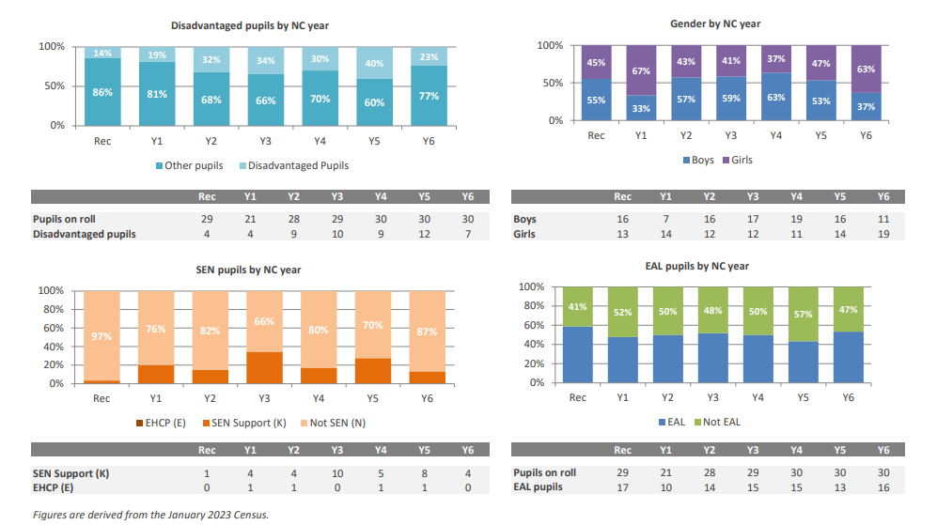
Context overview Dashboard
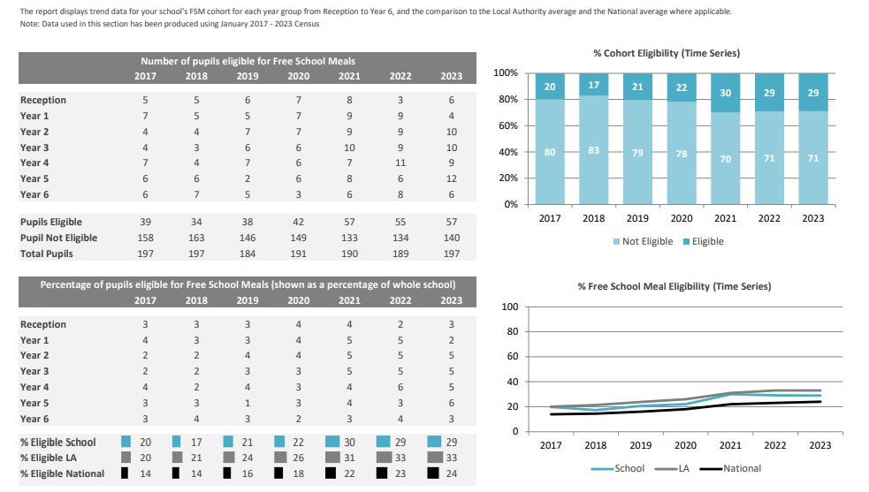

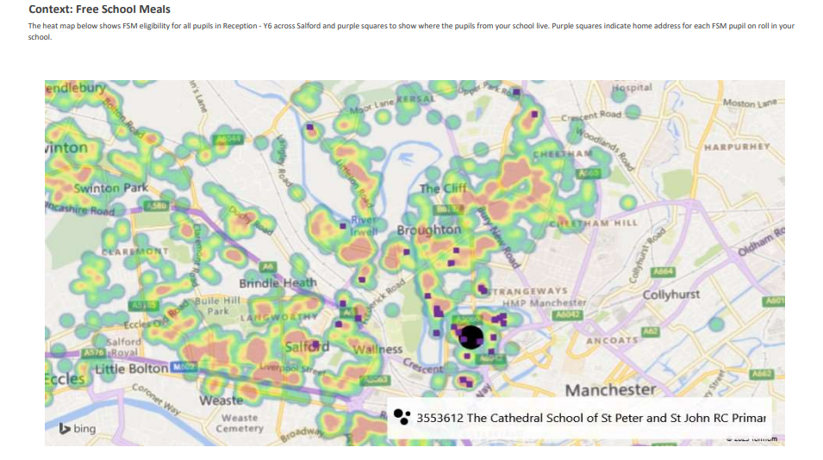
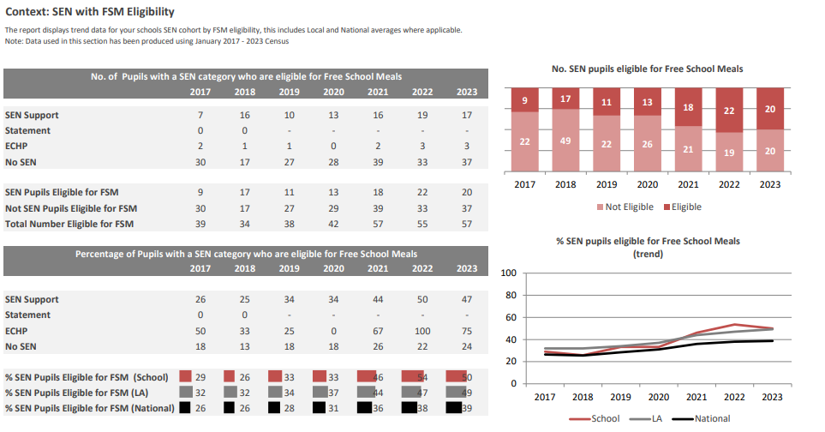

Ultimate Objectives
- To narrow and level the attainment gap between disadvantaged and non- disadvantaged pupils nationally
- For all disadvantaged pupils in school to exceed nationally expected progress rates to reach Age Related expectation and beyond at the end of Year 6 and thus achieve GCSE’s in English and Math’s - gaining the opportunity to have more choices due to their successes.
- To narrow the cultural Capital gap – giving the pupils experiences beyond the school gate to open their perspectives to the wider world and see it with experienced eyes and language to express themselves emotionally and academically.

The range of provision the Governors consider making for this group include and would not be limited to:
- Increasing where necessary the teaching capacity thus improving opportunities for effective teaching and accelerating progress
- To allocate a ‘Catch Up’ programme to each Year Group - providing small group work with an experienced teacher/HLTA/experienced teaching assistants - focus on overcoming gaps in learning
- 1-1 support
- Additional teaching and learning professional development opportunities provided through the national college, the local authority, teaching hubs and curriculum consultants or external agencies
- All our work through the pupil premium will be aimed at accelerating progress, moving children to at least age-related expectations.
- Pupil premium resources are to be used to target pupils on Free School Meals to achieve Age Related Expectations
- Pupil Premium funding will target those who are educationally and socially disadvantaged. enabling the children with the experiences and language to express themselves emotionally and academically
- Attendance/Punctuality tracking and monitoring -
- Transition from primary to secondary and transition internally EYFS – yr 1 year 2 – yr 3
learning support.
- Cultural Capital - Contribute to activities, educational visits and residential visits. Ensuring children have Additional first-hand experiences to be able to call upon in their learning in the classroom.
- To equip EYFS with resources to enhance provision facilitating speech and language skills, social skills and learning.
- Support the funding of specialist learning software.
- To allow the children to learn a musical instrument and participate in The Arts
- The children’s wellbeing is a focus – all children should feel safe and happy - Behaviour and nurture support throughout the day – including mindfulness / health and wellbeing activities – one to one therapy – group and classwork i.e. Happy Minds

This list is not exhaustive and will change according to the needs and support our socially and educationally disadvantaged pupils require.

Challenges
This details the key challenges to achievement that we have identified among our disadvantaged pupils.

Challenge Area | Detail of challenge
A | Weak Language, Communication and attention skills
B | Low attainment on entry to the Early Years Foundation Stage in all areas including intimate care and training.
C | Complex wellbeing and mindfulness issues pupils ill-equipped emotional literacy
D | Attendance and Punctuality issues. Pupils at persistent absences harmful to a child's future person and prospects, with a clear negative correlation identified between pupils who are persistently absent and their academic achievement levels.
E | Cultural capital Supporting pupils to exceed cultural norms involves providing opportunities for personal, physical, social, moral, spiritual, and cultural development that may not be readily accessible to them. For example, engaging pupils in sporting activities, or access to trips and experiences beyond their usual environment.
F | Early reading and mathematics understanding Reception year 1 and 2 – catch up yr 3 and 4
G | Reading into writing ‘Reading into Writing’ pupils who lack the knowledge and ability to use a range ambitious vocabulary and written techniques.
H | Mathematics fluency and reasoning dificulties

This explains the outcomes we are aiming for by the end of our current 3-year strategy plan, and how we will measure whether they have been achieved.

Intended outcome | Success criteria
Progress in Reading | Achieve above national average progress scores in KS2 Reading
Progress in Writing | Achieve above national average progress scores in KS2 Writing
Progress in Mathematics |  | Achieve above national average progress scores in KS2 Maths
Progress SEND |  | Progress SEND is in line with pupils across the school and above national average
Progress in EYFS |  | Increase percentage achieving a good level of development (EYFSP) to be in line with national
Phonics |  | Achieve above national average expected standard in PSC
Reading |  | Ensure all children have a good standard of reading and comprehension by the end of key stage 2
Other |  | Ensure attendance of disadvantaged pupils is 96% and above
Other |  | To promote cultural literacy through the curriculum and teaching so pupils have the knowledge and skills to talk with confidence about the subjects they study and the experiences they have.
This details how we intend to spend our pupil premium (and recovery premium funding) this academic year to address the challenges listed above.
Teaching – E.G (Professional Development ) Budgeted cost: 142,096 - £38 679 = 103,417

Activity | Evidence that supports this approach | Challenge Area addressed

Speech and  Language HLTA To  screen all children on entry and bespoke programmes are put in place.  NELI  Language Support)  WELCOMM KS1  and 2  (£10,300) | Underdeveloped Language and Communication skills. All nursery pupils are children are working in the pre-3 band and do not have the breadth of vocabulary that reflects their experiences on entry to Reception.  In KS1and KS2, children are unlikely to use talk to connect ideas and explain what is happening coherently. Although the academic language is increasingly applied – this still needs work for it to be applied fluently.  Higher than average numbers of children access SALT in Reception and key stage 1 of disadvantaged children access and will either require small group support or 1:1 support from the school speech and language therapy ( HLTA)  Expected success  All children working with the speech and language programme to become age related. | A  B  C  E  F  H
Speech Therapy ( HLTA) LEAD  Targeted pupils within class  Teaching Assistants  TA2 x2 - £7779 | On entry to Reception most children have low Language and Communication skills – 90% of disadvantaged children are working in the e reception band with 25% of disadvantaged children working significantly below in the pre3 band  Due to and poor socio-economic and disadvantaged background, children are unlikely to have the breadth of vocabulary,  Expected success  All children working with the speech and language programme to become age related.  Some KS1 and KS2, children are unlikely to use talk to connect ideas and explain what is happening coherently. Not being able to express themselves so that others can understand could lead to further difficulties in the future. The speech and language programme will enhance the pupils speaking and listening skills so that they understand and are understood.This will further enhance the pupils wellbeing. | A  B  C  E  F  G  H

SENDco time  Non- class based teacher utilising three days per week | 44.6 of disadvantaged children have SEND/ learning needs with 2C% with significant learning needs.  Children working within month age band on entry to Reception despite making accelerated progress, do not meet the required end of year ELG’s.  The additional teaching staff sees progress accelerated in KS1  Expected success  Increase the number of PP children with SEND accelerate progress with increased percentage at ARE by the end of the three years.  A higher % children working within age related expectations | A  B  C  E  F  G  H
Supply Cover £15,000 with additional to allow for health and wellbeing cover newly inducted staff | To enable the appraisal progress – to release the deputy head teacher - For SLT and subject leaders to be released for management time 1 day per term to ensure the progress and attainment reaches the potential and high expectations of the school  Staff members accessing CPD to have cover for their classes  Expected success  Developed subjects to enhance education and provision and quality of education. | A B C  E F G  H
Whole Staff CPD and wellbeing  £5000 | High quality staff CPD is essential to follow EEF principles. This is followed up during Staff meetings and INSET.  New teaching staff to be inducted and mentored  to access high quality writing training from a literacy consultant  Teachers to be given extra time for assessments – and feedback -  Expected success  Impact on quality of education, personal development and enhance knowledge and skills, cultural capital.  Staff feel mentally equipped to fulfil their role of class practitioner and subject lead | A  B  C  E  F  G  H
Mathematics White  Rose Resources  £5000 | The purchase of Mathematics White Rose resources year Reception – year 6 including homework books – this is effective practise 2 fold – high quality homework books – less stress of teachers preparation time.  Quality White Rose CPD and access for parents  Expected success  To ensure all children gain a secure and deep understanding of mathematical concepts and application | A H
Target Tracker  £1240 | Recording of assessment, groups of children, attendance and context is kept up to date. Enhance planning and assessment.  Expected success  To understand knowledge and skills of children to accelerate progress
Cornerstones curriculum | Implement and easily manage an ambitious primary curriculum or individual subjects. From sequenced, resourced curriculum projects to teaching and assessment tools, Maestro is the online curriculum and assessment platform with everything you need, all in one place.  Enables progress from nursery – year 6 reduces staff planning and research time
Reading books key stage 1 to year 3 to complement New Phonics and  Early Reading  Scheme  Little Wandle Revised Letters and Sounds – and Big Cat Collins group brown and grey book banding  £5000  Turing Maths Hub  First Class at  Number | Phonics National 2023 - 79% School Phonics – 67%  KS1 reading - National 2023 67% School 54% 2023  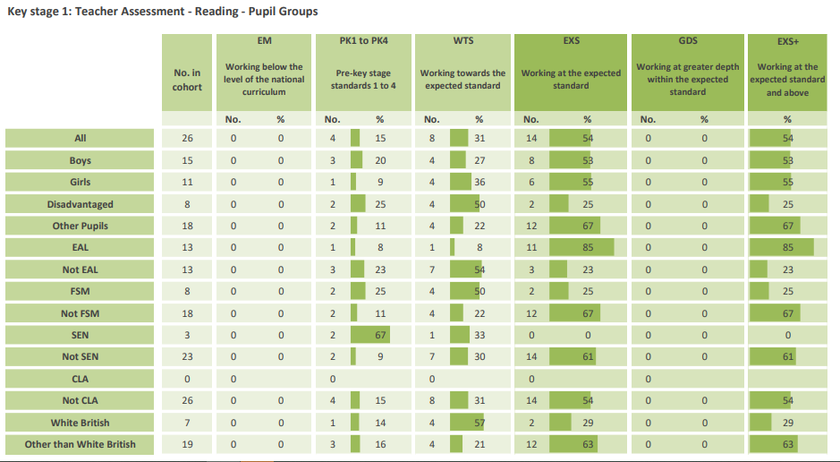  Re- deployment of Teaching assistants to meet the needs of small group phonic teaching and reading practice and after school booster for years 1 and 2  Utilise SENDco time to mentor key stage 1 teachers re – phonics and guided reading.  Parents information giving meetings including meet the teacher expectation meetings  An investment of new books and resources was undertaken to support the EEF research.  Expected success  Reading: Percentage increase in number of children meeting age related expectations  Yr 2 reading percentage to increase and to be in line with national average.  Pupils have a high level of understanding – comprehension – vocabulary  Maths: A more secure understanding of the mastery of number to enhance fluency | A  B  C  E  F  G
Teaching assistants targeted support small group work and or one to one  £23830 | - Targeted support given to pupils within and outside of the directed timetable. Teaching assistants are deployed throughout the school for the purposes of phonics and reading support following a structured timetable.  - Each teaching assistants have targets to meet each year in respect of the pupils they support – times table learning – spelling, academic vocabulary pre - teaching and overreaching  Expected success  For targeted children to make accelerated progress, diminishing gap | A  B  C  D  E  F  G  H

Targeted academic support (for example, tutoring, one to one support, structured interventions
Budgeted cost: £ 103,417- £34,881 = £68,536

Activity | Evidence that supports this approach | Challenge Areas addressed

Online resources  £2081 | All online resources utilised to enhance the teaching and learning as a whole class / group work and one to one.  Pupils have the opportunity to access the online learning from home ensuring no disadvantage to online resources received as a general household amenity.  Home access to Purple Mash – Spelling Frame – Discovery ( Espresso)  Expected success  Online resources have developed expertise in each subjects Greater participation in subject specific hubs – building  connections enhances provision  Children successfully accessing learning remotely  Children taking responsibility for own learning  Children developing a greater awareness of online safety | A  B  C  E  F  G  H

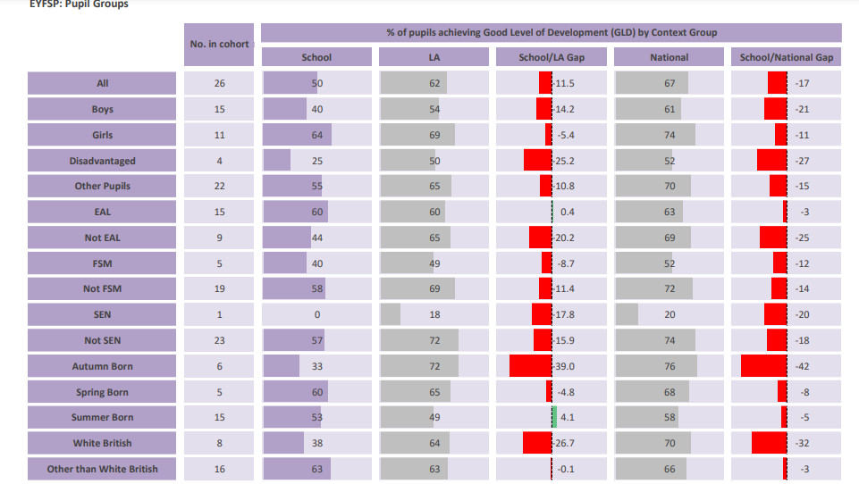

EYFS Resourcing to meet the need of the new EY Curriculum  £7000 | Over recent years, the majority of children in the reception cohort have achieved a Good Level of Development by the end of the Foundation Stage 2017 – 77% 2018 58% 2019 68%, COVID has had a major factor in the decrease of the GLD level and the phonics achievement  and this is again the case in 2023, with 50 % achieving GLD.  These figures reflect the fact that many children join The Cathedral  School of St Peter and ST John RC with very low levels of development  Expected success  All children achieve a good level of development | A  B  C  E  F  G  H

Wider Strategies (for example, related to attendance, behaviour and wellbeing)
Budgeted cost: 68,536 - £54,935 = £13,601
Support the Nurture and Behaviour of all pupils  HLTA and  resources  £37,435 | With the additional increase in Social Service involvement nationally, it is essential that we know our children and can spot triggers which will affect learning. The pupils and parents who are in need to extra support with their health - wellbeing and low self-esteem Early Help is a strength of the school The pastoral lead is highly visible to the whole school community from the opening the morning gate ( accessible to parents who would not generally seek to come into school for help.) – to drop in sessions in the school playground at breaktimes. From timetabled whole class sessions RHSE and mindfulness ( Happy Minds) to Lego therapy with small groups and or one to one sessions. From bereavement therapy – to referrals to CAMHs and Early Help.  This is not a comprehensive list of roles and activities the Pastoral Lead undertakes –  Expected success  School is a sanctuary of wellbeing where all feel safe and happy and know who to turn to when they are not | A  B  C  D  E  F  G  H
Pastoral outings and resources – afterschool clubs /Pyramid to work with vulnerable pupils to ensure they can access learning  £3000 | More frequent wellbeing difficulties meaning PP pupils are more likely not to access the curriculum due to the lack of emotional literacy – speech and language causing frustration which impacts on their academic progress.  Pupils who join school in key stage 2 are closely monitored and strategies are placed to enhance health and wellbeing  Existing interventions have had a positive impact on wellbeing. Incident of pupils identified reduce quickly  Expected success  Further reduction in the percentage of pupil referrals and of the need for pupils to participate in pastoral activities | A  B  C  D  E  G
Attendance resources and monitoring  £2000 | The attendance lead continues to have a great impact on the attendance and punctuality of vulnerable families. The attendance percentage has risen from to and the persistent absence has decreased since the last inspection. School continues to place vital importance to attendance and punctuality. All parents and children understand the need for this and are happy to try as hard as they can to have a greater attendance percentage and good punctuality.  We see attendance as the catalyst to all learning and punctuality as good practice as a characteristic which will see the children  in good stead for the future including the world of work hence all areas.  Expected success  All children have an attendance of at least 96% | A  B  C  D  E  F  G  H
Lunchtime Support to provide high quality games and activities to engage pupils – TA3  Lunchtime playground buddies – led by the pastoral lead  £5000 | Healthy living and healthy practices are very much encouraged. Pupils are happy to participate and see the need for a healthy lifestyle.  The buddies nurture the younger pupils’ social skills through play.  Expected success  All children become healthier in mind and body due to greater access to healthy choices and activities | C E

Residential/education al visits/ out of school competitions Costs  £4000 | Pupils who are educationally disadvantaged require the firsthand experiences of those who have the cultural capital.  As EYFS – KS1 and KS2  The children through their time at The Cathedral School of St Peter and ST John will experience visits to:  Theatre for plays and concerts Museums  River walk and pond dipping  Residentials with outdoor pursuits  Animal orientated parks  General local park investigations i.e. Peel and Heaton Park  Experience journeys on buses- trams- trains  The seaside  The countryside  Forest School Activities  We encourage Active learning.  Expected success  Enhance provision and quality of education, children have greater experience of cultural capital outings and remember them – learn more, remember more | A  B  C  D  E  F  G  H
Music – Ukuleles  £1200 | Every child has the right to learn to play an instrument | E

Wellbeing related resources | Resources to improve pupil wellbeing  Aquarium used as a calming effect  Living eggs scheme – for pupils to understand the importance of nurture – calm and accountability  Pantomime – escape from the norm – cultural capital  Water sport – relief from everyday pressures for year 6 – bonding practise – cultural capital – facing fears and resilience
After/before school club resources  £1500 | All children have the opportunity to access afterschool clubs from Martial Arts to boardgames - From art club to music –  From sports clubs – Science  All year 1 – year 6 have the opportunity to attend a morning move session 5 times per week. Gardening club for children yrs 1-6  Expected success  Children have opportunities to experience a wider range of activities and experiences | A B C D E F  G H
CPoms  £800 | It is essential that all safeguarding and child protection details are recorded in a way that those who need to know are informed – that patterns of behaviour are analysed – that attendance and the possible impact on learning is observed and any outside agency meeting minutes are noted in real time.  Expected success  Records centralised and Patterns are easily identified for better safeguarding protocols.

