Science Curriculum Map EYFS - Year 6
 | Autumn 1 | Autumn 2 | Spring 1 | Spring 2 | Summer 1 |  | Summer 2
Nursery | Nursery Rhymes | Night and day | It’s Cold out there | New Life | What’s in the garden? |  | People who help us
 | All about Me  My body  Autumn  Children will use all their senses in hands on exploration of natural materials.  Explore collections of materials with similar and/or different properties. | Day and Night  Seasons-Winter Difference between day and night  Animals that hibernate  Water freezing | Winter –  Ice  Children will use all their senses in hands on exploration of natural materials.  With support the children use magnifying glasses to make observations. | Seasons- Spring  Plant seeds and care for growing plants.  Understand the key features of the life cycle of a  plant and an animal.  Understand the key features of the life cycle of a  plant and an animal. (chicks)  Begin to understand the need to respect and care  for the natural environment and all living things. | Mini beasts  Observe life cycle of a butterfly in Nursery Explore mini beasts and outdoors.  With support the children use magnifying glasses to make observations.  Seasons- Summer  Understand the key features of the life cycle of a  plant and an animal.  (butterfly) |  | Talk about the lives of the people around them and their roles in society.  Talking about how doctors help our bodies → understanding the human body (natural world)  Firefighters and water → changes in materials  Caring for animals (vets) → animals and living things
Curriculum Enhancements |  |  | Airport – watch planes  Transport museum | Farm visit  Eggs/chicks | Butterflies |  | Professional visitors – talk about their jobs
Reception | Lets Explore  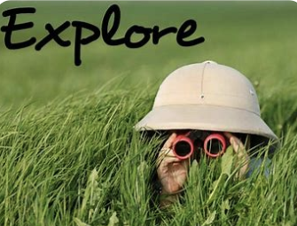 | Marvellous Machines  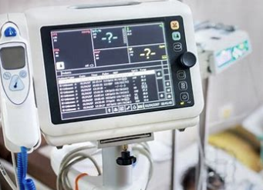 | Long Ago  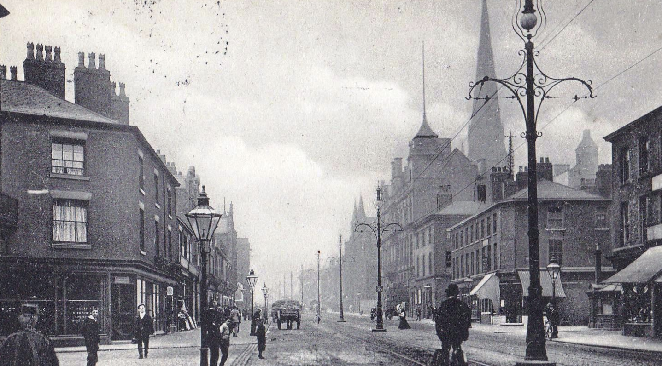 | Ready Steady Grow  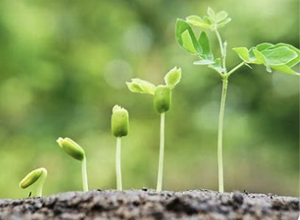 | Animal Safari  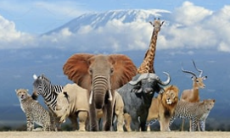 |  | On the Beach  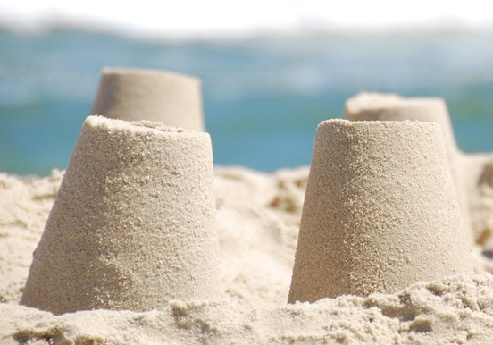
Mini project | Build it up  Signs of Autumn  Black History Month: Mae Jemison  Harvest celebrations. | Puppets and Pop ups | Stories and Rhymes  Signs of Winter | Signs of Spring | Creep, Crawl and Wriggle  Signs of Summer |  | Move it | Moving on
UW -Possible links with Science Understanding of the world ELG: The Natural World. Children at the expected level of development will:

• Explore the natural world around them, making observations and drawing pictures of animals and plants
• Know some similarities and differences between the natural world around them and contrasting environments, drawing on their experiences and what has been read in class.
• Understand some important processes and changes in the natural world around them, including the seasons and changing states of matter
Enrichment Opportunities | Exploring our school grounds.  Explore our local area National fitness day:24/09  National Recycling week: 22nd-28th September | Visit to Peel Park  Use electrical appliances to cook, such as vegetable soup, bread and toast | Visit to Salford Museum | Visit to RHS Garden centre  Living eggs | Peel park visit  Caterpillars  Earth Day: 22/04 |  | Seaside visit: Southport
 | - Sort and group materials and resources and talk about how they are similar or different.  - Sensory walk: What can you see, hear, smell, feel?  - Describe what, why and how something was made and compare with others.  - Exploring using torches. | - Use technology to record their work and ideas.  - Develop scientific knowledge through play activities, sharing stories and non-fiction books and discussion.  - Shadow puppets. | - To learn about and observe seasonal changes (Winter).  - Develop an understanding of freezing and melting: Read the Snowmans Coat: Brenda and Stuart Naylor.  - Use technology to record their work and ideas. | - To learn about and observe seasonal changes and (Spring)  - Develop an understanding of what plants need to grow.  - Parts of plant.  - Planting: Observe and record (Diary)  - Where does our food comes from? Food sorting.  - Animals born in spring.  - Life Cycle: Chicken/Hen, frog. | - Observe and draw pictures of animals and plants.  - Learn about common features of Mammals, Reptiles and birds.  - Carnivores, Herbivores and Omnivores.  - To learn about and observe seasonal changes (Summer).  - Develop an understanding of what we need to stay safe during the summer months.  - Investigate materials: Water resistant/absorbent.  - Life Cycle: Caterpillar.  - Bee investigation. |  | - Floating and sinking.  - Healthy body (importance of physical exercise).  - Shadows.  - Bouncing balls investigation.
Year 1 | Animals including humans  Senses  - Identify, name, draw and label the basic parts of the human body and say which part of the body is associated with each sense. | Plants  (Plant bulbs)  - Identify and name a variety of common wild and garden plants, including deciduous and evergreen trees.  - Identify and describe the basic structure of a variety of common flowering plants, including trees. | Everyday materials  Name describe and sort everyday materials  - Distinguish between an object and the material from which it is made.  - Identify and name a variety of everyday materials, including wood, plastic, glass, metal, water, and rock.  - Describe the simple physical properties of a variety of everyday materials.  Compare and group together a variety of everyday materials on the basis of their simple physical properties. |  | Animals  - Identify and name a variety of common animals including fish, amphibians, reptiles, birds and mammals.  - Identify and name a variety of common animals that are carnivores, herbivores and omnivores.  Describe and compare the structure of a variety of common animals (fish, amphibians, reptiles, birds and mammals, and including pets).
Seasonal Changes
- Observe changes across the four seasons.
- Observe and describe weather associated with the seasons and how day length varies.

Plants
(harvest from bulbs planted autumn 2)

Pupils should use the local environment throughout the year to explore and answer questions about plants growing in their habitat. Where possible, they should observe the growth of flowers and vegetables that they have planted.

Enrichment Opportunities |  | RHS Visit |  | British Science week
Year 2 | Everyday materials  - Identify and compare the suitability of a variety of everyday materials, including wood, metal, plastic, glass, brick, rock, paper and cardboard for particular uses.  - Find out how the shapes of solid objects made from some materials can be changed by squashing, bending, twisting and stretching. | Living things and their habitats - Enviroment  - Notice that animals, have offspring which grow into adults.  - Find out about and describe the basic needs of animals, for survival (water, food and air).  Living things and their habitats  - Explore and compare the differences between things that are living, dead, and things that have never been alive.  - Identify that most living things live in habitats to which they are suited and describe how different habitats provide for the basic needs of different kinds of animals and plants, and how they depend on each other.  - Identify and name a variety of plants and animals in their habitats, including micro-habitats.  - Describe how animals obtain their food from plants and other animals, using the idea of a simple food chain, and identify and name different sources of food. |  | Plants  - Observe and describe how seeds and bulbs grow into mature plants.  - Find out and describe how plants need water, light and a suitable temperature to grow and stay healthy. | Health  Animals, including Humans  How we Grow and Stay Healthy  - Notice that humans, have offspring which grow into adults.  - Find out about and describe the basic needs of humans, for survival (water, food and air).  - Describe the importance for humans of exercise.  - Eating the right amounts of different types of food, and hygiene.
Enrichment Opportunities |  |  |  | RHS visit  British Science week
Year 3 | Forces and magnets  Forces and magnets  - Compare how some things move on different surfaces.  - Notice that some forces need contact between two objects but magnetic forces can act at a distance.  - Observe how magnets attract or repel each other and attract some materials and not others.  - Compare and group together a variety of everyday materials on the basis of whether they are attracted to a magnet, and identify some magnetic materials.  - Describe magnets as having two poles.  Predict whether two magnets will attract or repel each other, depending on which poles are facing. | Rocks  - Compare and group together different kinds of rocks on the basis of their appearance and simple physical properties.  - Describe in simple terms how fossils are formed when things that have lived are trapped within rock.  - Recognise that soils are made from rocks and organic matter.  Rocks and soils can feel and look different.  Rocks and soils can be different in different places/environments. | Light  Year 3 – Light  Pupils should be taught to:  - Recognise that they need light in order to see things and that dark is the absence of light.  - Recognise that light from the sun can be dangerous and that there are ways to protect their eyes.  - Recognise that shadows are formed when the light from a light source is blocked by a solid object .  - Find patterns in the way that the size of shadows change. | Plants  Identify and describe the functions of different parts of flowering plants: roots, stem/trunk, leaves and flowers.  Explore the requirements of plants for life and growth (air, light, water, nutrients from soil, and room to grow) and how they vary from plant to plant.  Investigate the way in which water is transported within plants.  Explore the part that flowers play in the life cycle of flowering plants, including pollination, seed formation and seed dispersal. | Animals including Humans  Animals, including Humans  Health and Nutrition  - Identify that animals, including humans, need the right types and amount of nutrition, and that they cannot make their own food; they get nutrition from what they eat. |  | Animals including Humans  Animals, Including Humans  Humans – Skeletons and Movement  - Identify that humans and some other animals have skeletons and muscles for support, protection and movement.
Enrichment Opportunities |  |  |  | RHS visit  British Science week |  |  | MOSI
Year 4 | Living things  Living things and their habitats  - recognise that living things can be grouped in a variety of ways  - explore and use classification keys to help group, identify and name a variety of living things in their local and wider environment  - construct and interpret a variety of food chains, identifying producers, predators and prey (NB: this point also in ‘Animals – Teeth, eating and digestion’)  - Recognise that environments can change and that this can sometimes pose dangers to living things. | Electricity  Electricity  - Identify common appliances that run on electricity.  - Construct a simple series electrical circuit, identifying and naming its basic parts, including cells, wires, bulbs, switches and buzzers.  - Identify whether a lamp will light in a simple series circuit, based on whether the lamp is part of a complete loop with a battery.  - Recognise that a switch opens and closes a circuit and associate this with whether or not a lamp lights in a simple series circuit.  - Recognise some common conductors and insulators, and associate metals with being good conductors. | Materials and their properties  States of Matter  - Compare and group materials together, according to whether they are solids, liquids or gases.  Solids, liquids and gases can be identified by their observable properties.  Solids have a fixed size and shape (the size and shape can be changed but it remains the same after the action).  Liquids can pour and take the shape of the container in which they are put.  Liquids form a pool not a pile.  Solids in the form of powders can pour as if they were liquids but make a pile not a pool.  Gases fill the container in which they are put.  Gases escape from an unsealed container.  Gases can be made smaller by squeezing/pressure.  Liquids and gases can flow.  - Observe that some materials change state when they are heated or cooled, and measure or research the temperature at which this happens in degrees Celsius (°C).  - Identify the part played by evaporation and condensation in the water cycle and associate the rate of evaporation with temperature. |  | Sound  Vibrations  - Identify how sounds are made, associating some of them with something vibrating.  - Recognise that vibrations from sounds travel through a medium to the ear.  - Find patterns between the volume of a sound and the strength of the vibrations that produced it.  - Recognise that sounds get fainter as the distance from the sound source increases.  Pitch  - Find patterns between the pitch of a sound and features of the object that produced it.  Muffling/blocking sounds  - Recognise that vibrations from sounds travel through a medium to the ear. |  | Animals, Including Humans  Humans –  Teeth and Digestion  - Describe the simple functions of the basic parts of the digestive system in humans.  - Identify the different types of teeth in humans and their simple functions.  - Construct and interpret a variety of food chains, identifying producers, predators and prey (NB: this point can be taught during the year 4 unit linked to environment).
Enrichment Opportunities | RHS Visit | MOSI – Light show | British Science week
Year 5 | Forces  - Explain that unsupported objects fall towards the Earth because of the force of gravity acting between the Earth and the falling object.  - Identify the effects of air resistance, water resistance and friction, that act between moving surfaces | Materials  Properties  Properties  - Compare and group together everyday materials on the basis of their properties, including their hardness, solubility, transparency, conductivity (electrical and thermal), and response to magnets  - Give reasons, based on evidence from comparative and fair tests, for the particular uses of everyday materials, including metals, wood and plastic  Compare a variety of materials and measure their effectiveness (e.g. hardness, strength, flexibility, solubility, transparency, thermal conductivity, electrical conductivity)  Temperature and Thermal Insulation  Heat always moves from hot to cold.  Some materials (insulators) are better at slowing down the movement of heat than others.  Objects/liquids will warm up or cool down until they reach the temperature of their surroundings. | Light  Earth and Space  - Describe the movement of the Earth, and other planets, relative to the Sun in the solar system.  - Describe the movement of the Moon relative to the Earth.  - Describe the Sun, Earth and Moon as approximately spherical bodies.  - Use the idea of the Earth’s rotation to explain day and night.  - The Earth spins once around its own axis in 24 hours, giving day and night.  The Earth orbits the Sun in one year.  We can see the Moon because the Sun's light reflects off it.  The Moon orbits the Earth in approximately 28 days and changes to the appearance of the moon are evidence of this.  The Sun appears to move across the sky from East to West and this causes shadows to change during the day.  Changes to shadow length over a day or changes to sunrise and sunset times over a year are evidence supporting the movement of the Earth. | Living things  - Describe the changes as humans develop to old age.  Living Things and their Habitats  – see Environment unit  - Observing life cycles of plants in the environment. | Reversible and irreversible changes  Properties and Changes of Materials  Reversible changes - Mixing and Separating Insoluble & Soluble Materials  - Know that some materials will dissolve in liquid to form a solution, and describe how to recover a substance from a solution.  - Use knowledge of solids, liquids and gases to decide how mixtures might be separated, including through filtering, sieving and evaporating  - Demonstrate that dissolving, mixing and changes of state are reversible changes.  Properties and Changes of Materials  Irreversible changes - Changes that form new materials  Explain that some changes result in the formation of new materials, and that this kind of change is not usually reversible, including changes associated with burning, and the action of acid on bicarbonate of soda. |  | Forces  Levers and pulleys  - Recognise that some mechanisms, including levers, pulleys and gears, allow a smaller force to have a greater effect.  After exploring the different types of forces in the ‘Friction, air resistance and water resistance’ unit (FORCES A – ) (including push, pull, and gravity too) children could be given the opportunity to apply their learning.  Introducing Levers, Pulleys, Gears and Simple Machines  Explore the effects of levers, pulleys, inclines/ramps and gears.
Enrichment Opportunities |  |  |  | RHS Visit  British Science week
Year 6 | Classification  Living things and their habitats  Classification  - Describe how living things are classified into broad groups according to common observable characteristics and based on similarities and differences, including micro-organisms, plants and animals.  - Give reasons for classifying plants and animals based on specific characteristics. | Inheritance and adaptations  Evolution and inheritance  - Recognise that living things have changed over time and that fossils provide information about living things that inhabited the Earth millions of years ago.  - Recognise that living things produce offspring of the same kind, but normally offspring vary and are not identical to their parents.  Identify how animals and plants are adapted to suit their environment in different ways and that adaptation may lead to evolution. | Electricity  - Associate the brightness of a lamp or the volume of a buzzer with the number and voltage of cells used in the circuit.  - Compare and give reasons for variations in how components. function, including the brightness of bulbs, the loudness of buzzers and the on/off position of switches.  - Use recognised symbols when representing a simple circuit in a diagram.  - Circuit diagrams can be used to construct a variety of more complex circuits predicting whether they will ‘work’. | Light  - Recognise that light appears to travel in straight lines.  - Use the idea that light travels in straight lines to explain that objects are seen because they give out or reflect light into the eye.  - Explain that we see things because the light that travels from light sources to our eyes or from light sources to objects and then to our eyes.  Use the idea that light travels in straight lines to explain why shadows have the same shape as the objects that cast them. | Animals, Including Humans  Circulatory System and Exercise  - Identify and name the main parts of the human circulatory system, and describe the functions of the heart, blood vessels and blood.  - Recognise the impact of exercise on the way their bodies function.  - Describe the ways in which nutrients and water are transported within animals, including humans.  Year 6 – Animals, including Humans  Keeping Healthy - Diet and Lifestyle  - Recognise the impact of diet, exercise, drugs and lifestyle on the way their bodies function.
Enrichment Opportunities | RHS Visit | RHS Visit |  | British Science week

